DATA ANALYTICS MINI PROJECT
USING EXCEL & POWER BI
NAME: R. INDUMATHI
SUBMISSION DATE:13.08.2026

SYNOPSIS:
- Introduction

- Removing duplicates
- Handling missing values

- Standardizing formats

- Creating calculated fields

- Filtering and sorting

- Pivot table

- Introduction:
To perform real world raw data -analysis using Excel for data cleaning and transformation. To use removing duplicates and handle missing values and use formulae and functions then sorting and filtering to create pivot tables.
- Removing duplicates:

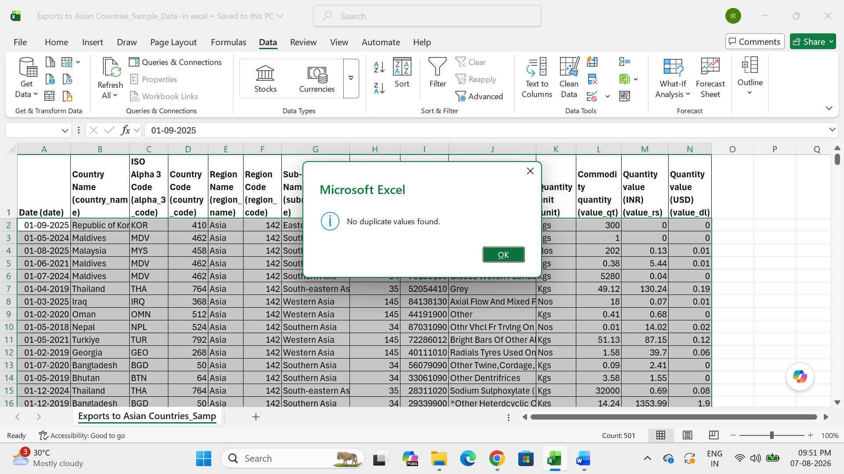
- To select table, go to click data and duplicate value
- The result was no duplicate value found.
- Handling missing values:
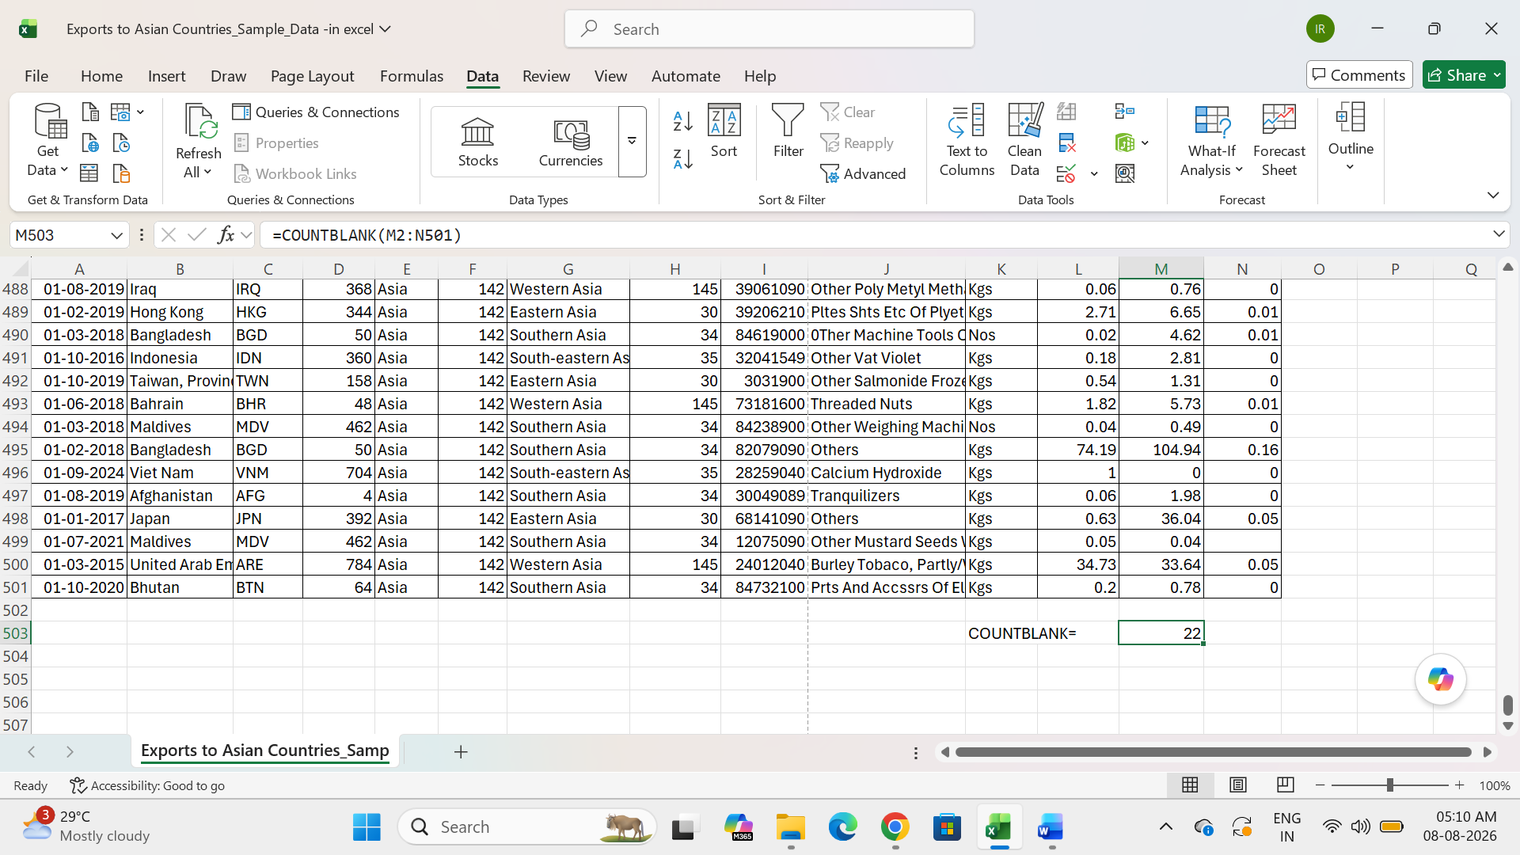
- To select M, N column using COUNT BLANK function.
- Two columns overall empty cells result of that function.

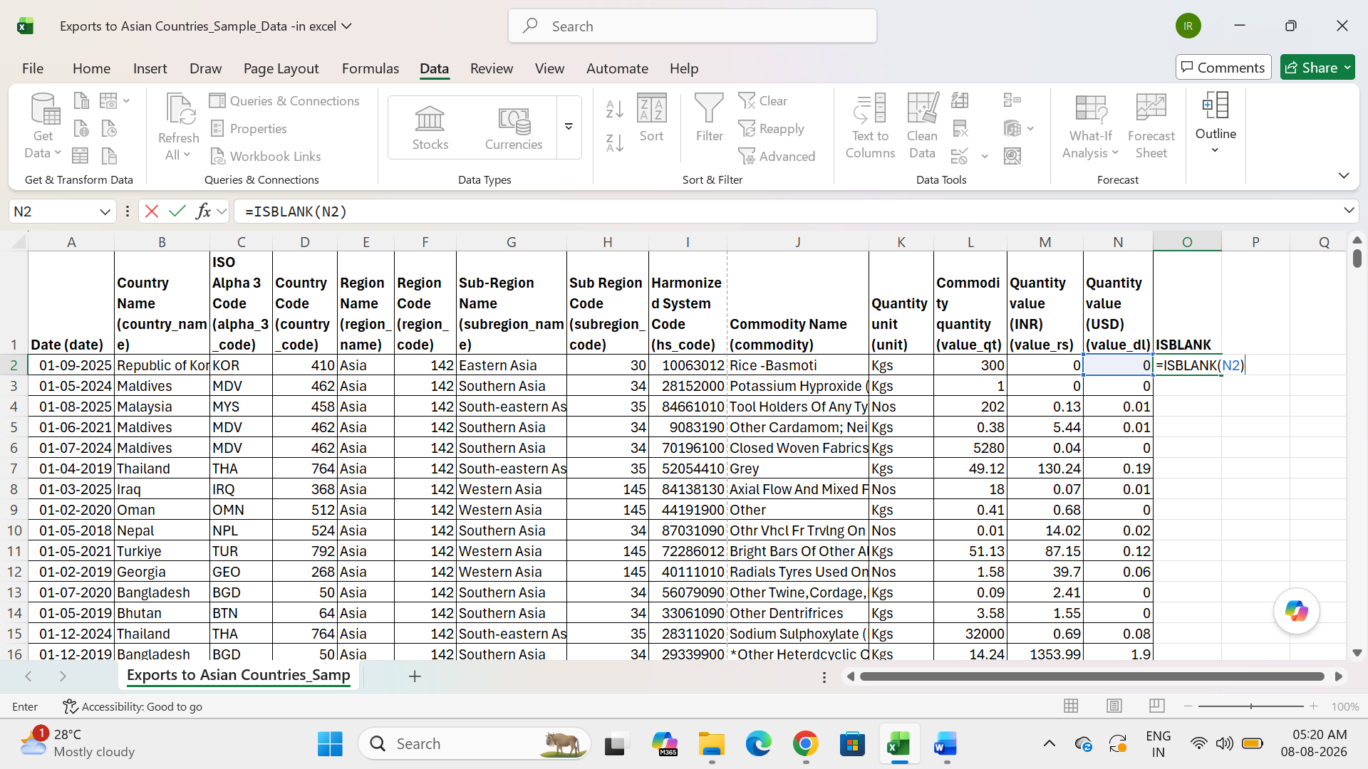

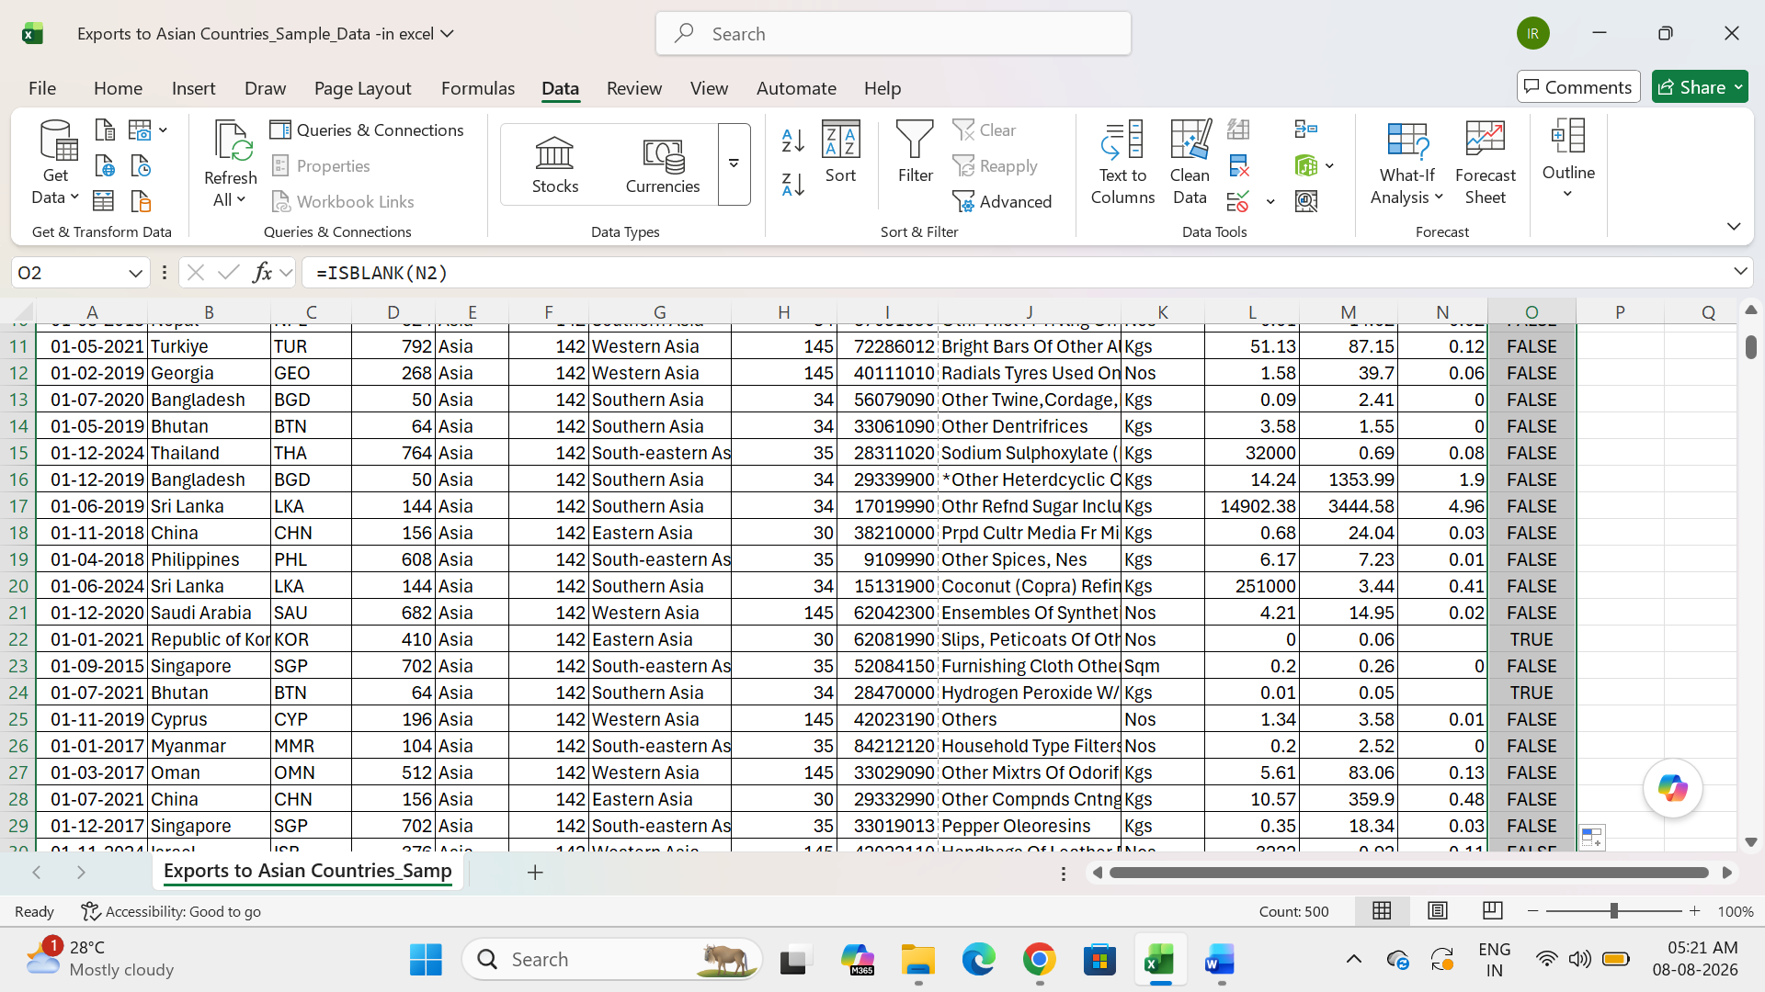
- To use ISBLANK function applied N column and display result of blank cell is TRUE, then fill the column is the result of FALSE.
- Replacing values:
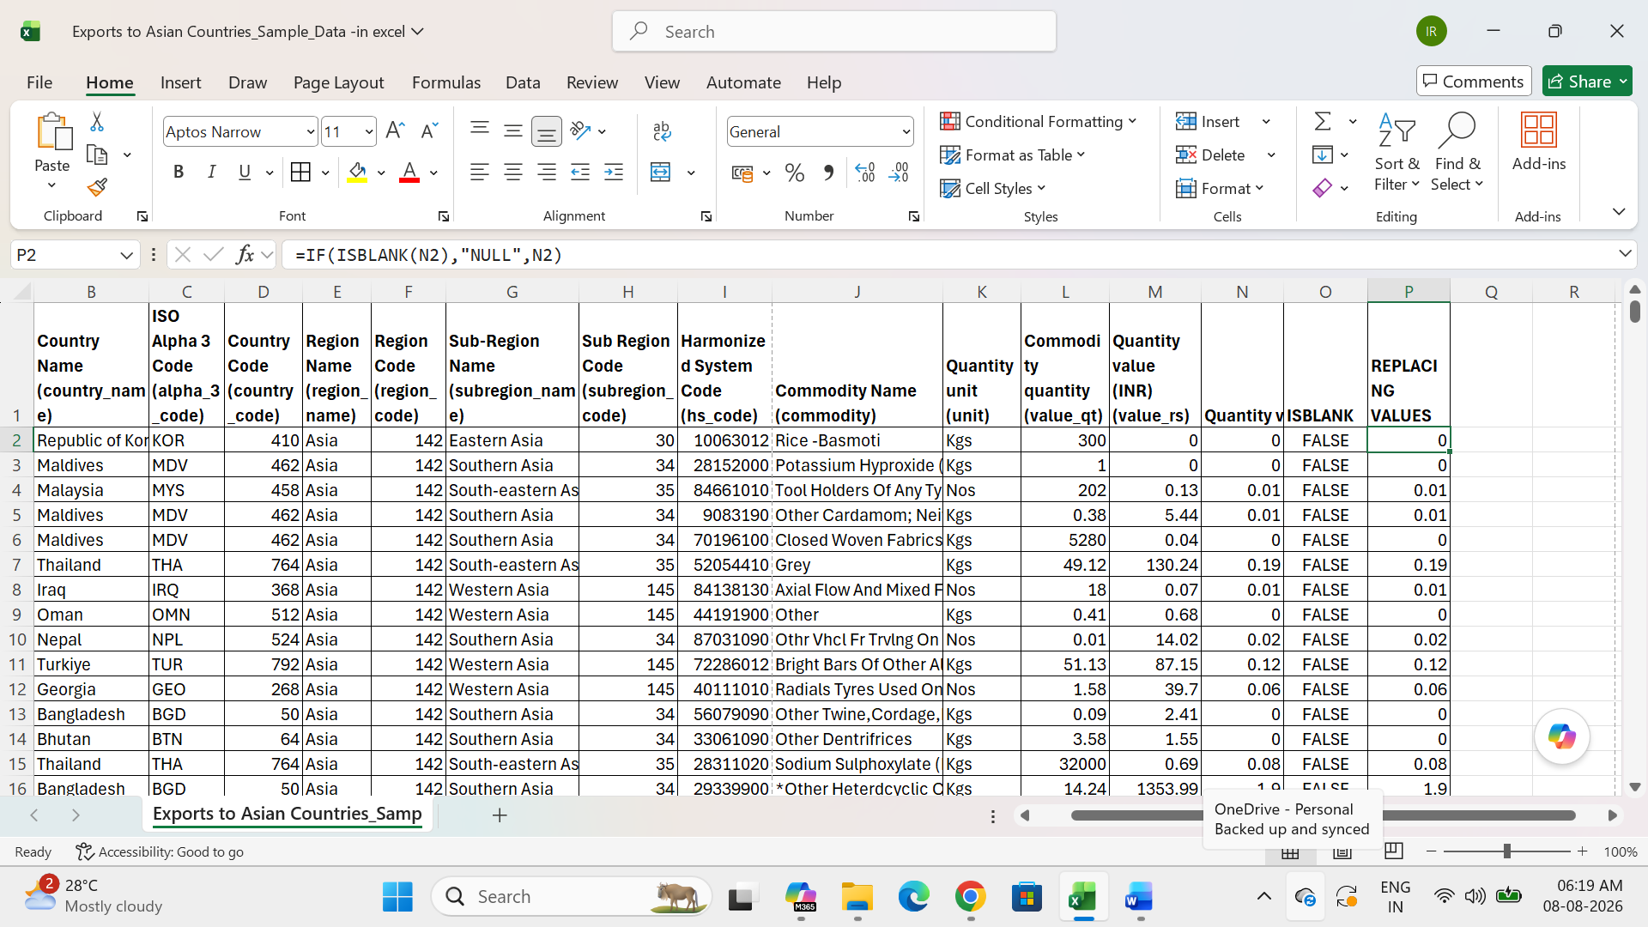
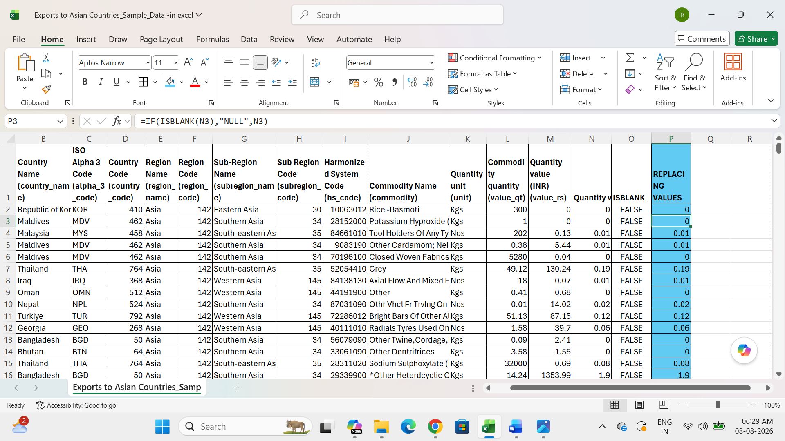
- To use if condition applied to isblank then result of N column blank cell is returns NULL otherwise return original values.
- Standardizing formats:
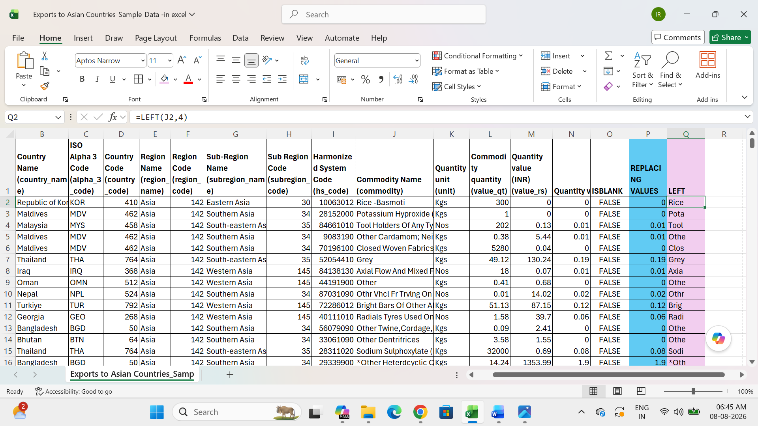

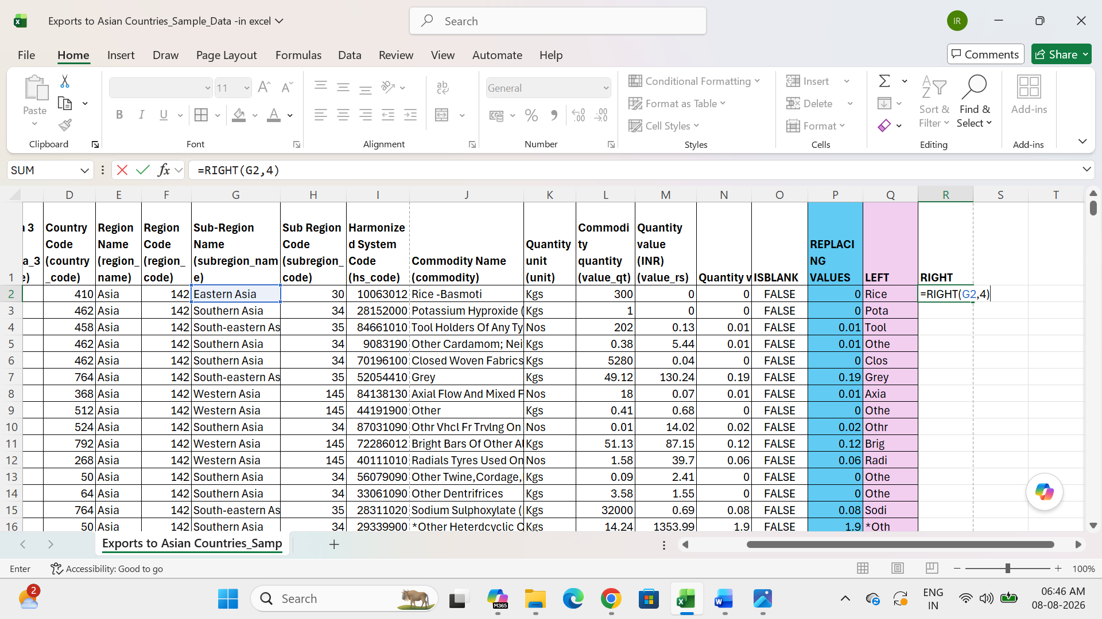

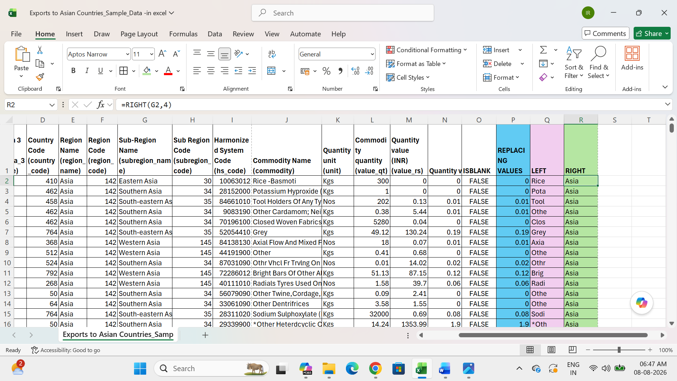

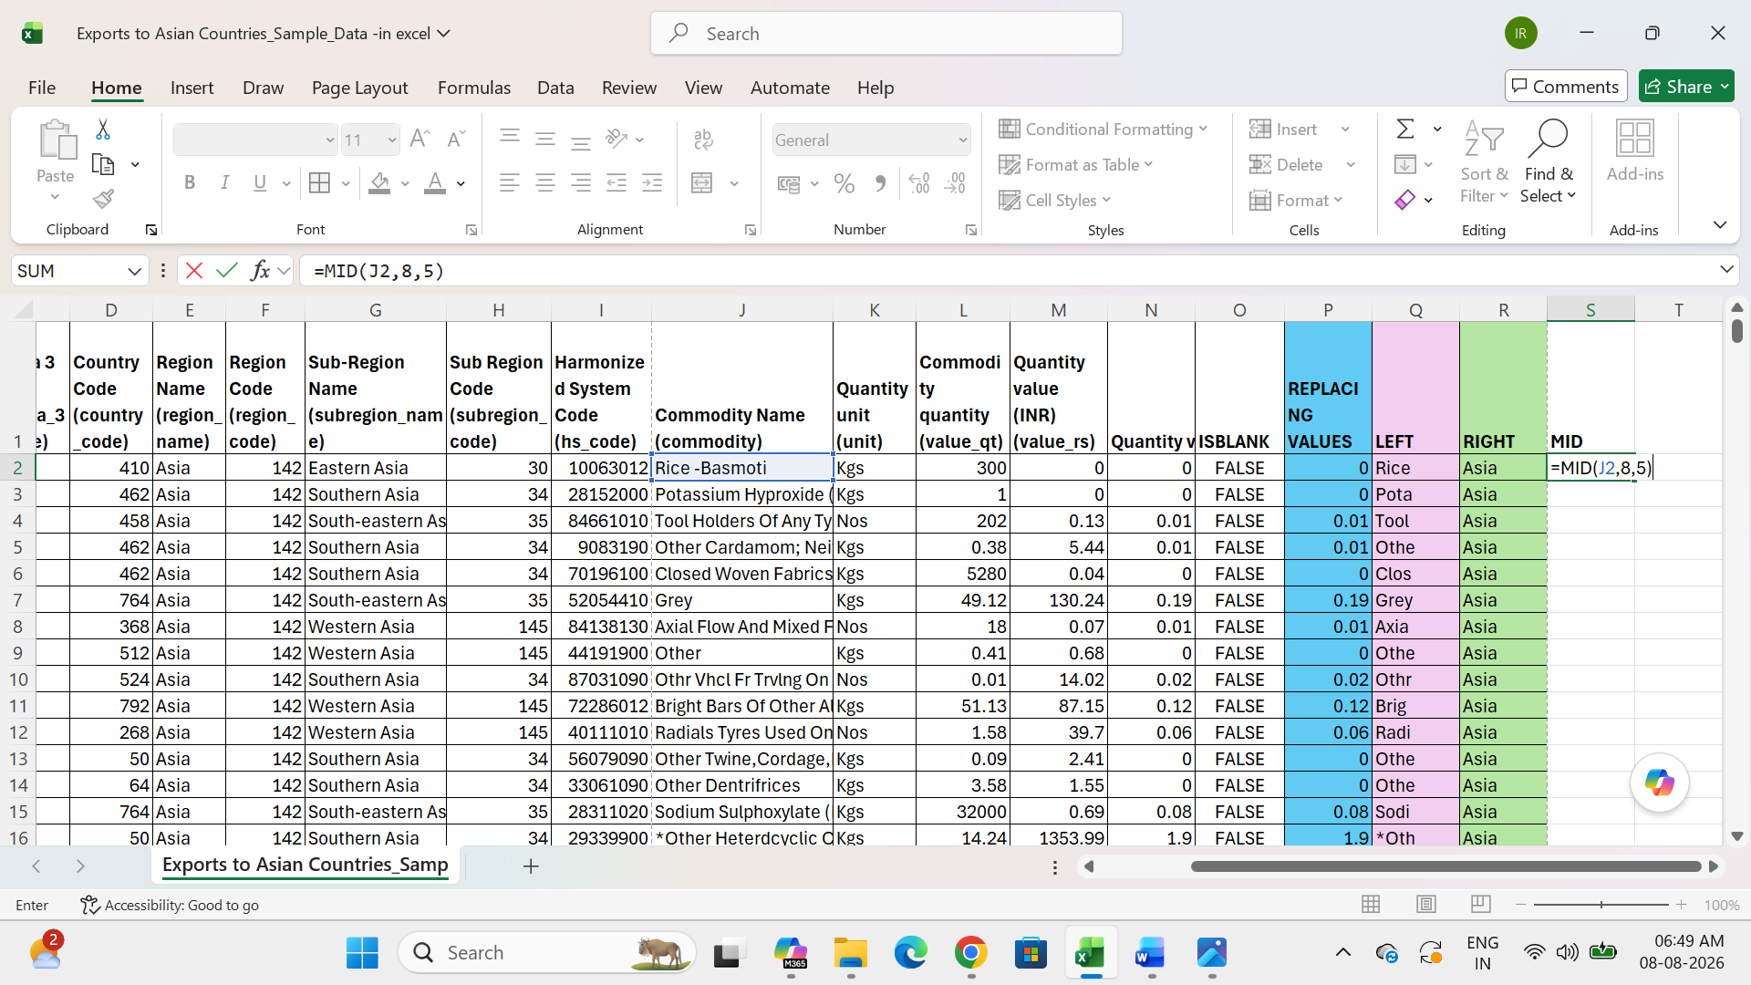

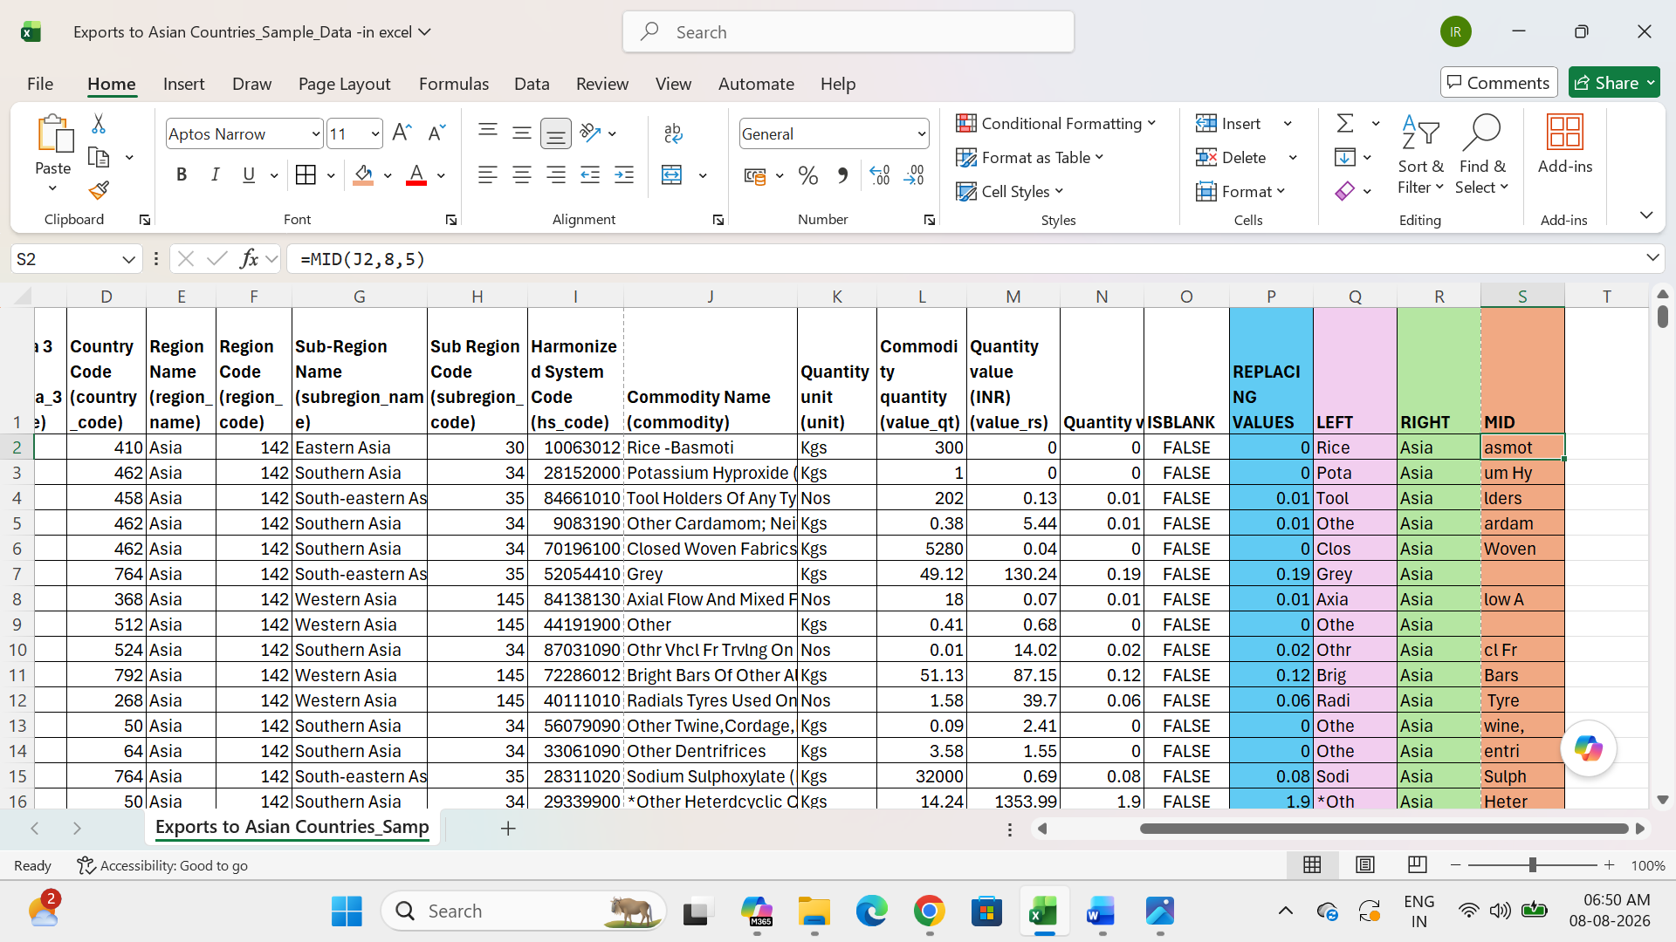
- To use LEFT, RIGHT, MID functions then returns the values of J, G columns.
- The right function uses G column to return 4 values.
- The left function uses J column to return 4 values.
- MID function use J column to return mid values start to 8 and return 4 values.

Use currency:
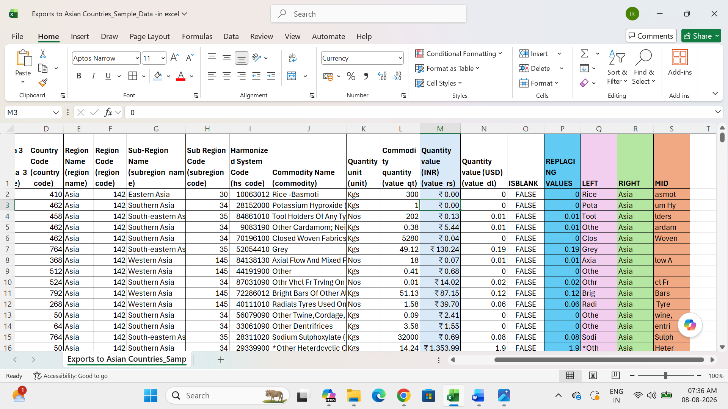
Use Proper case:
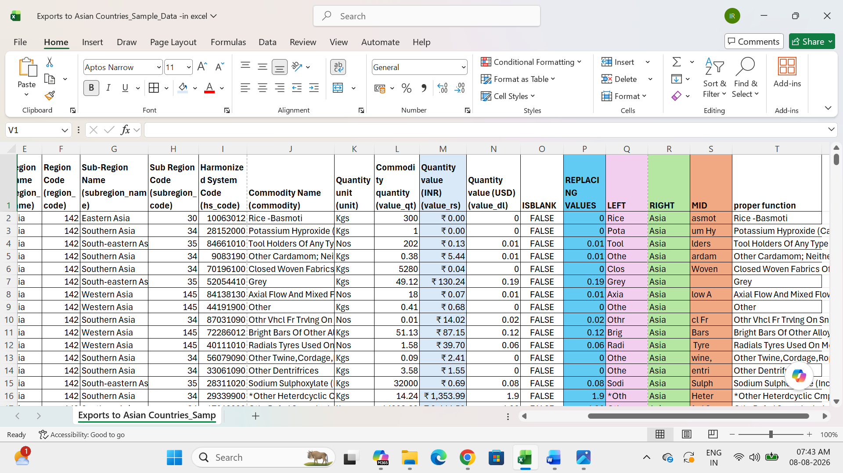

- Center alignment:
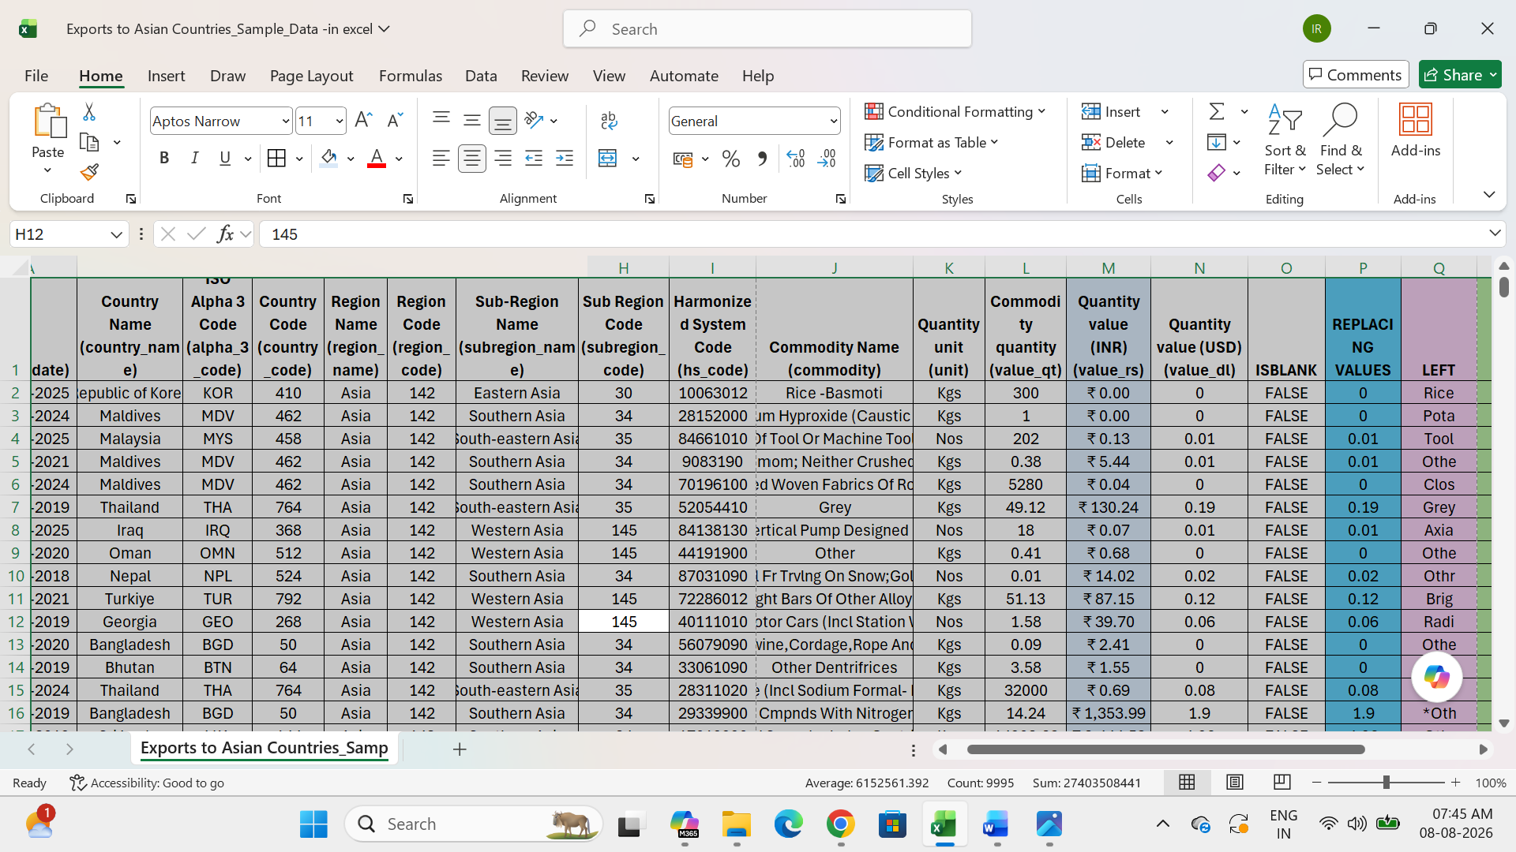

- Creating calculated fields:
- Use sum fun():
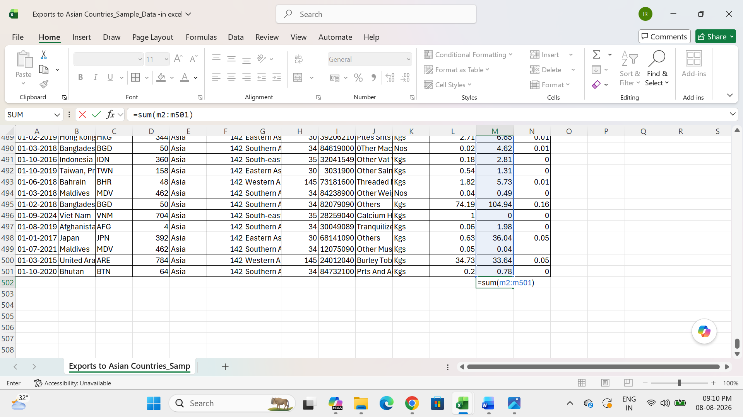

Result:
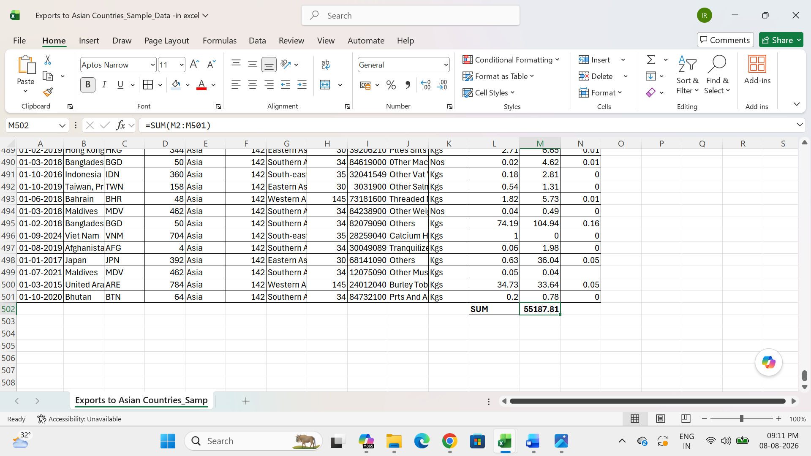
- Use average fun ():

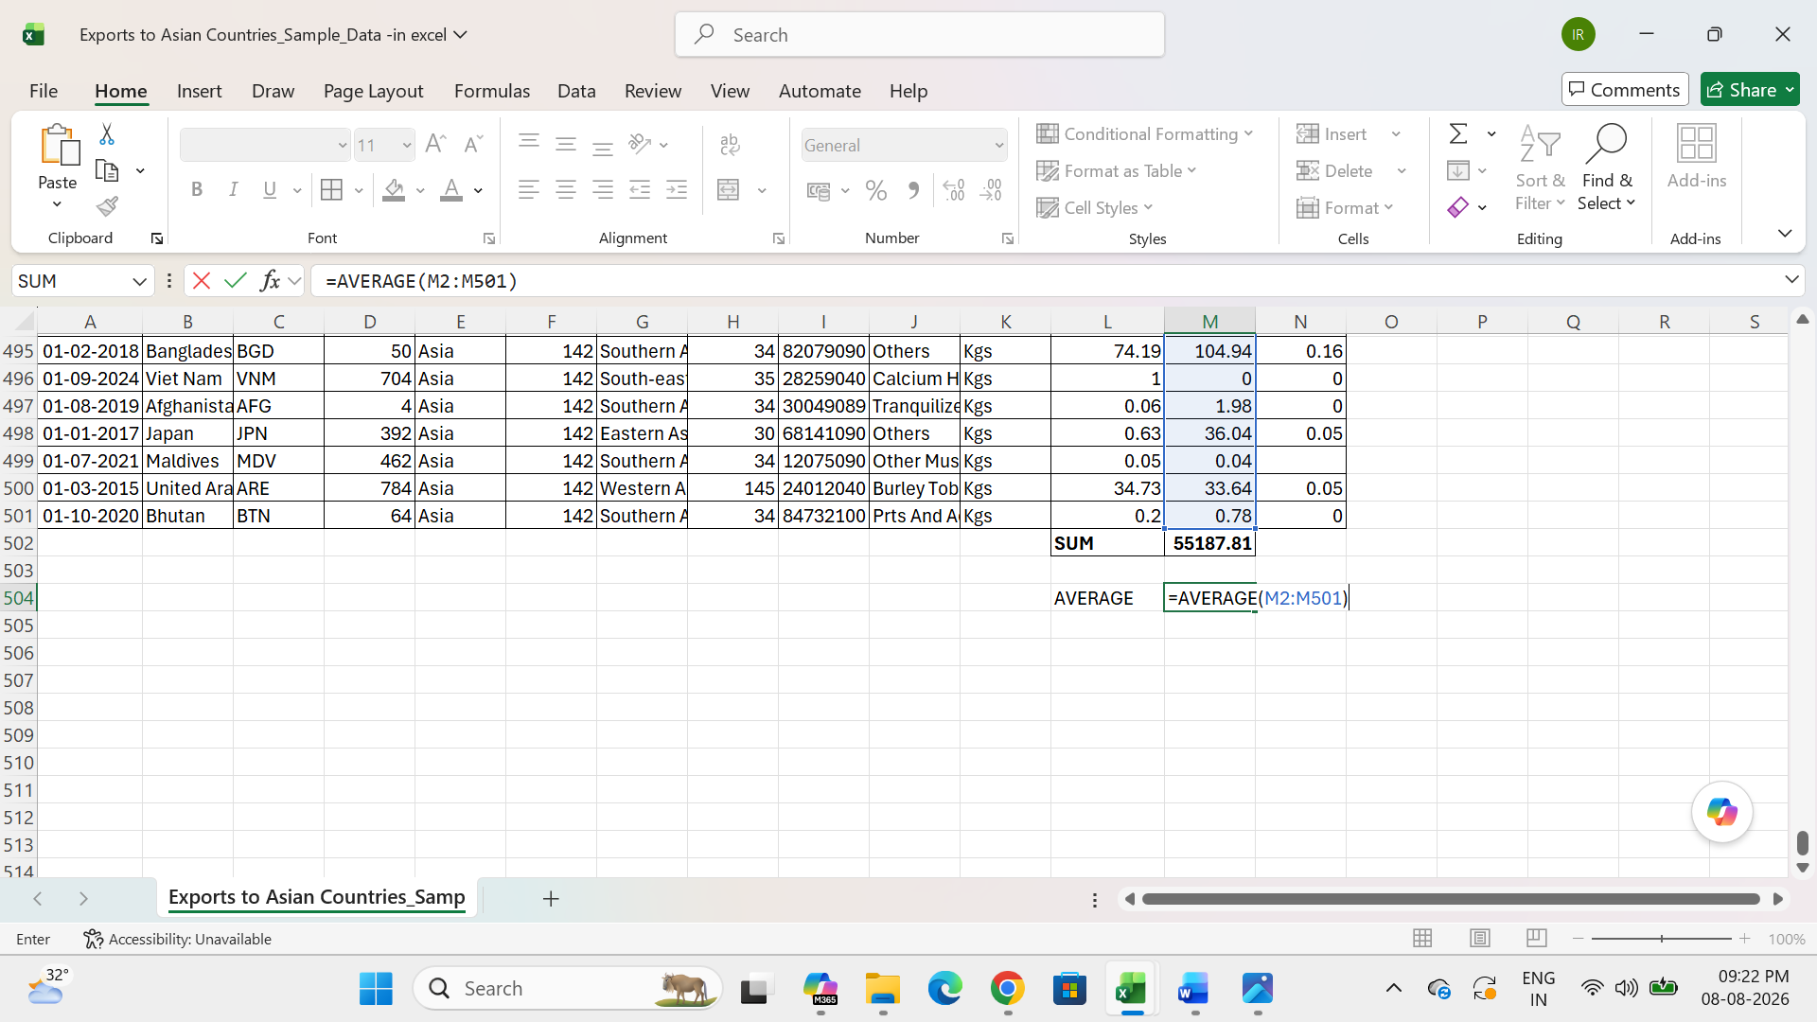

Result:
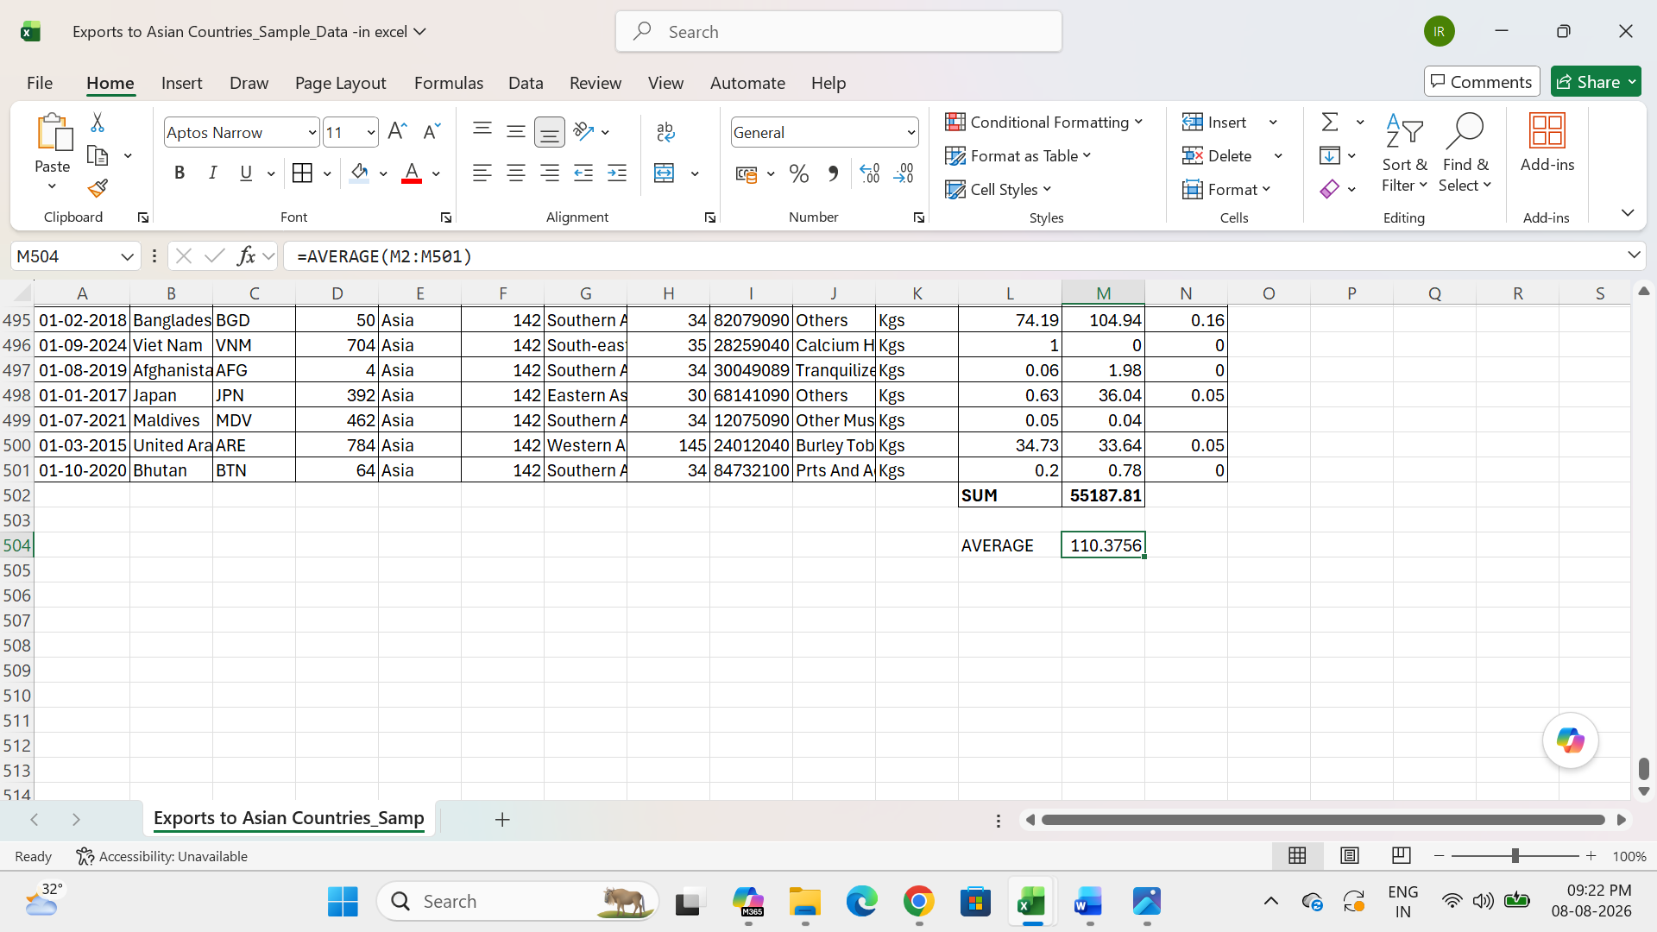

- Use VLOOKUP fun ():
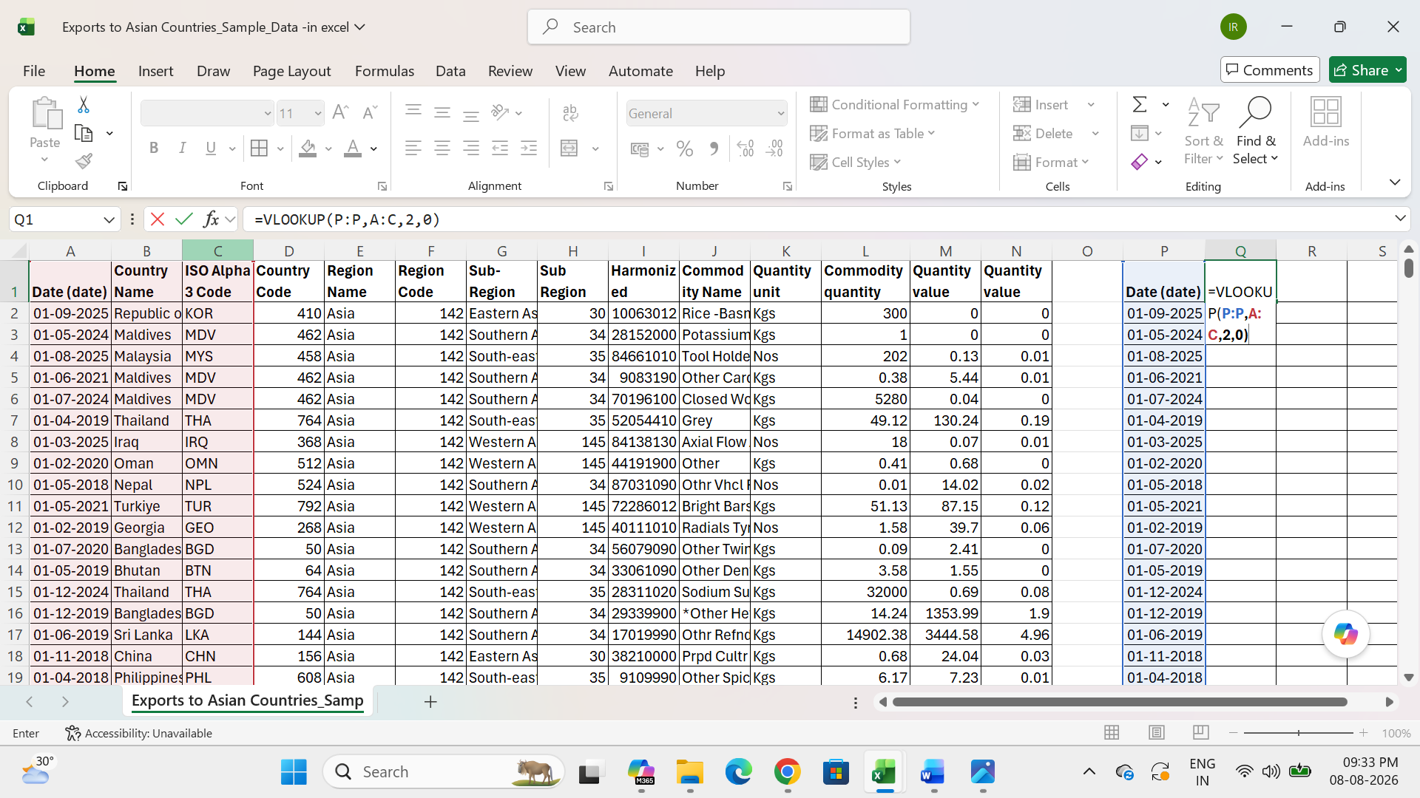

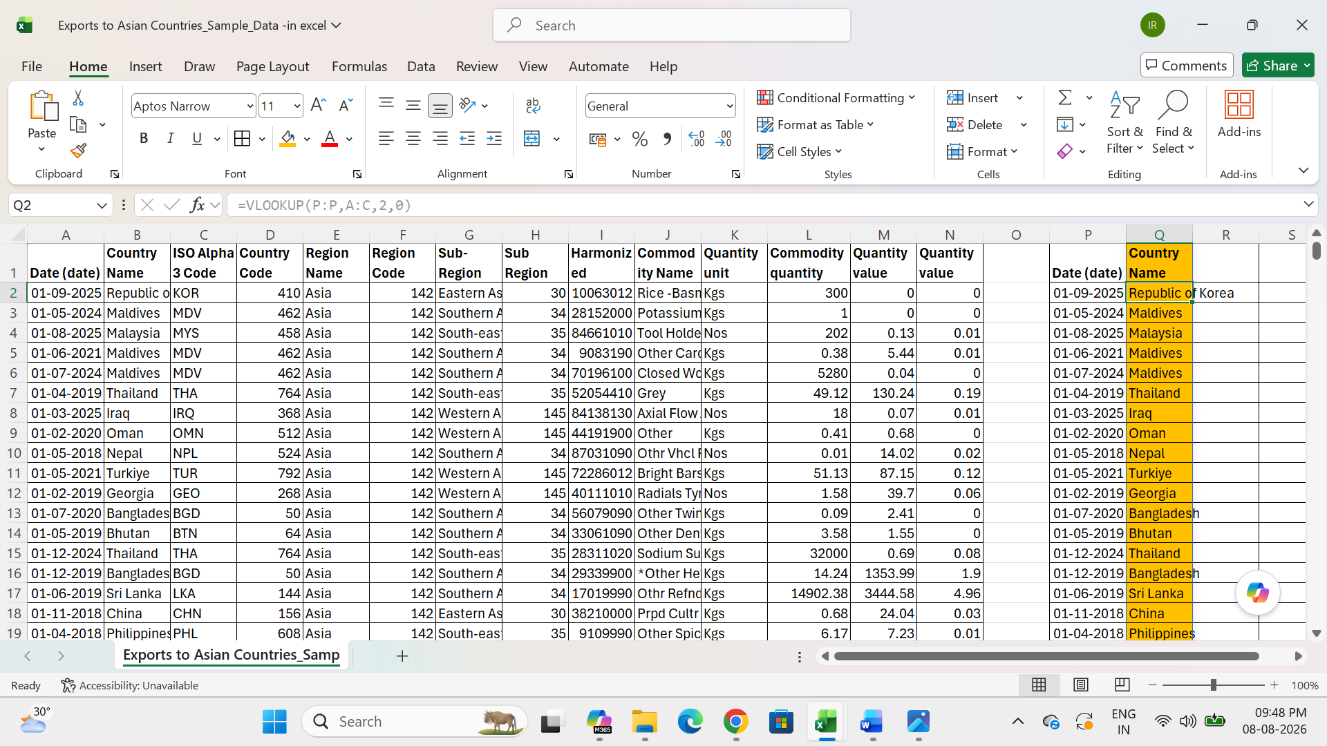

- Filtering and sorting:
Sorting:
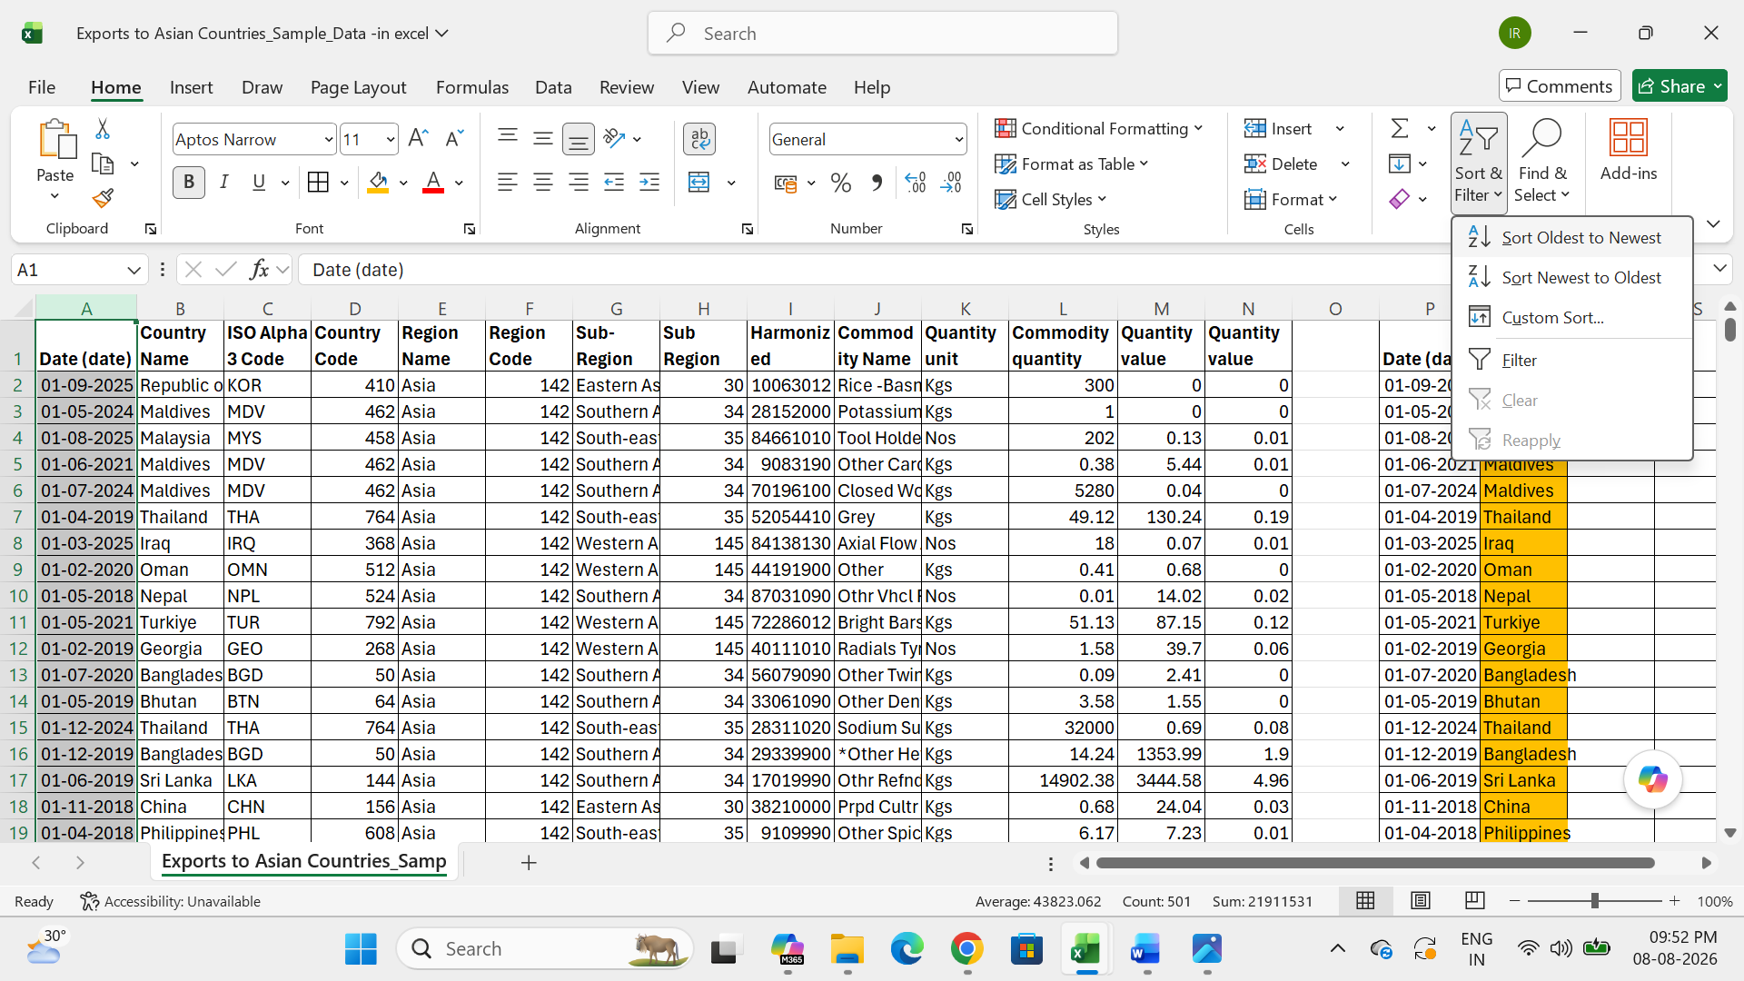

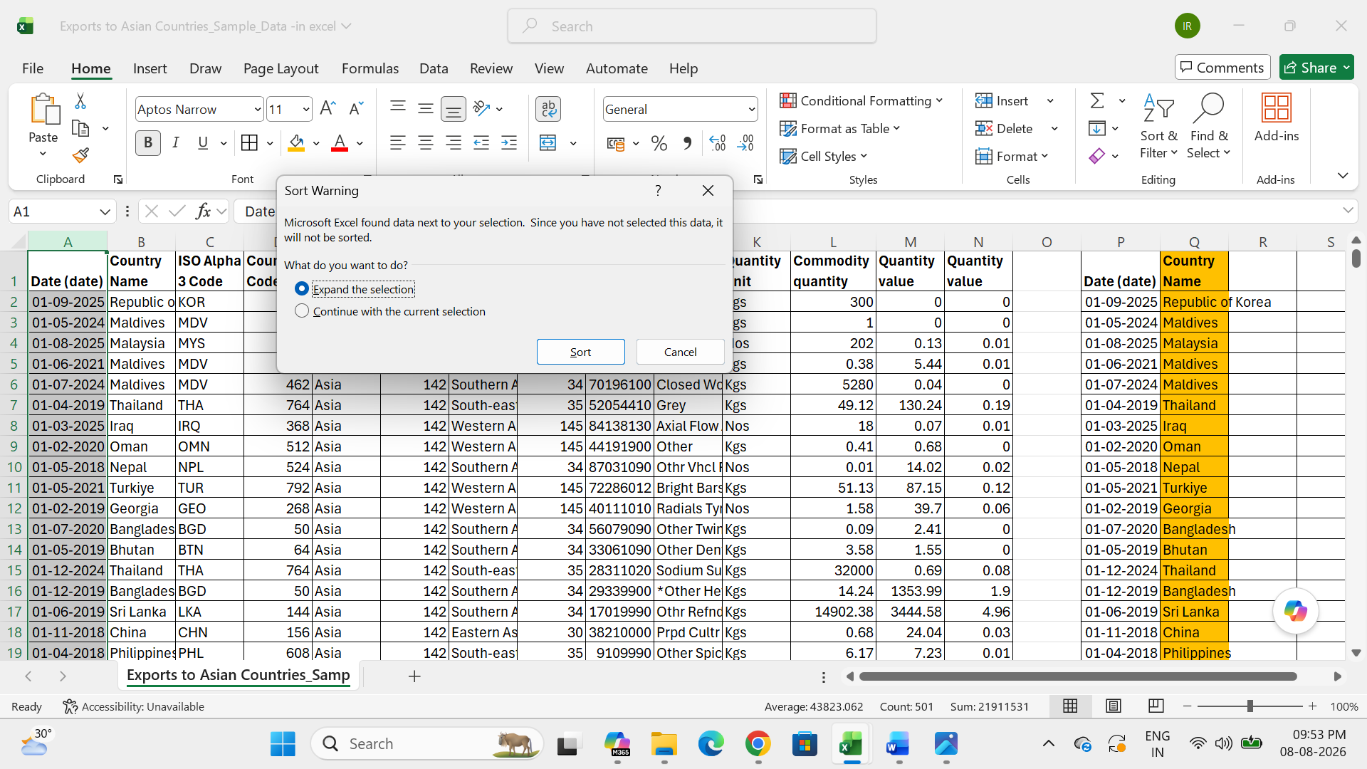

Result:
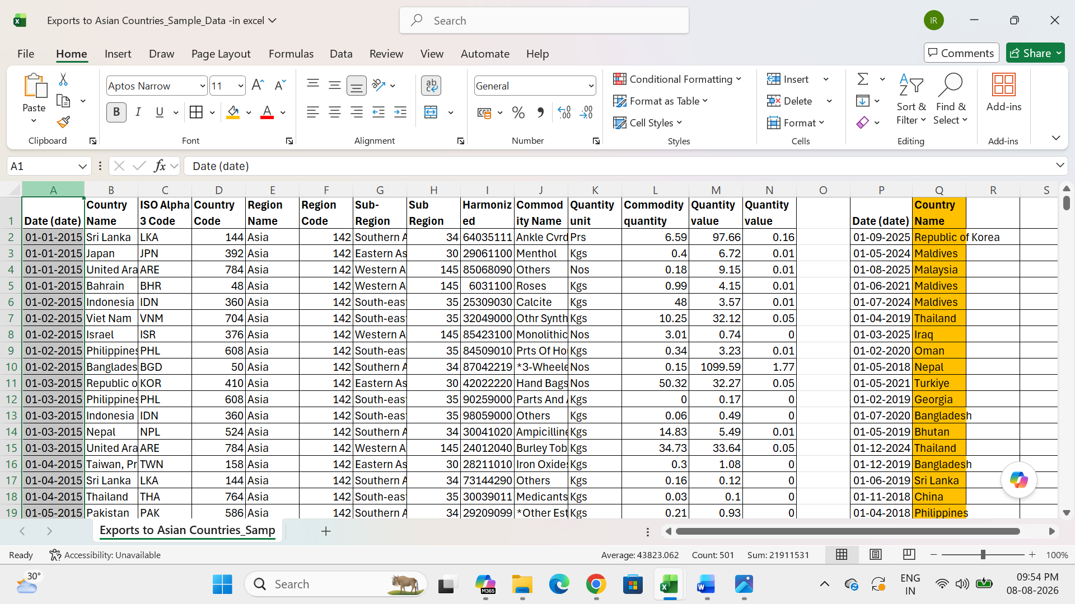

Filter:
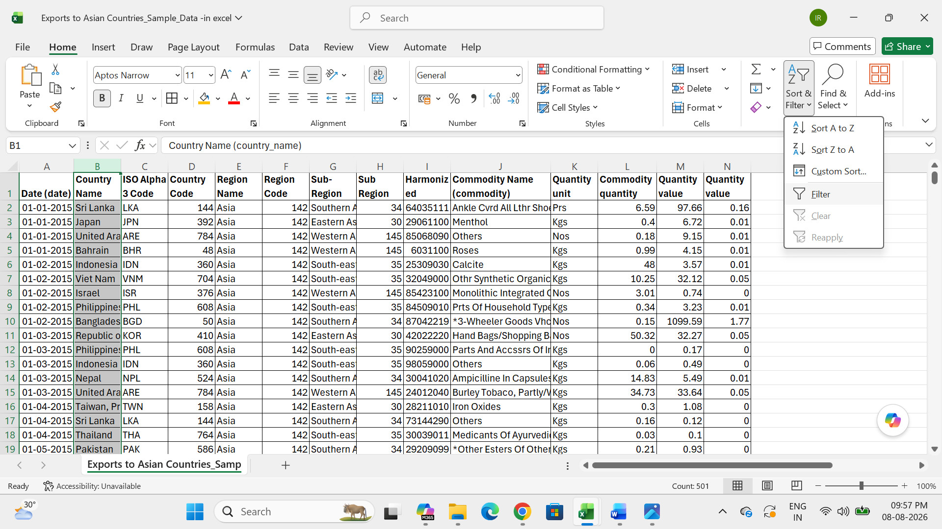

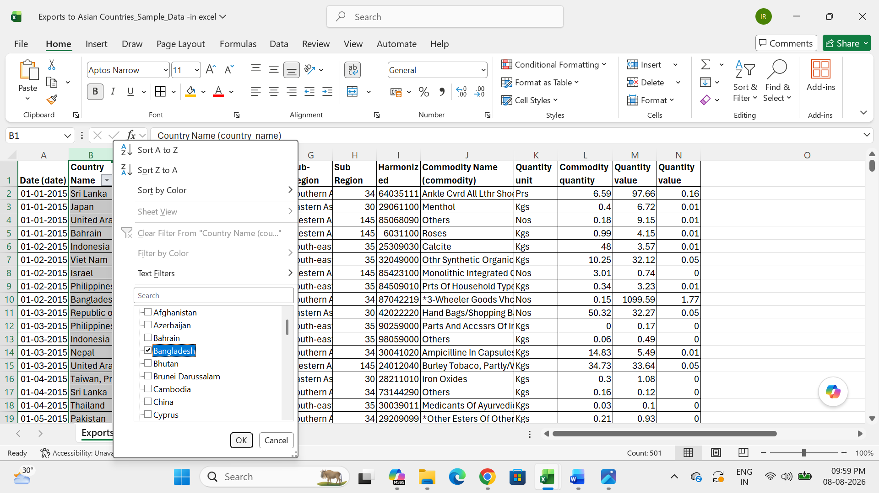

Result:
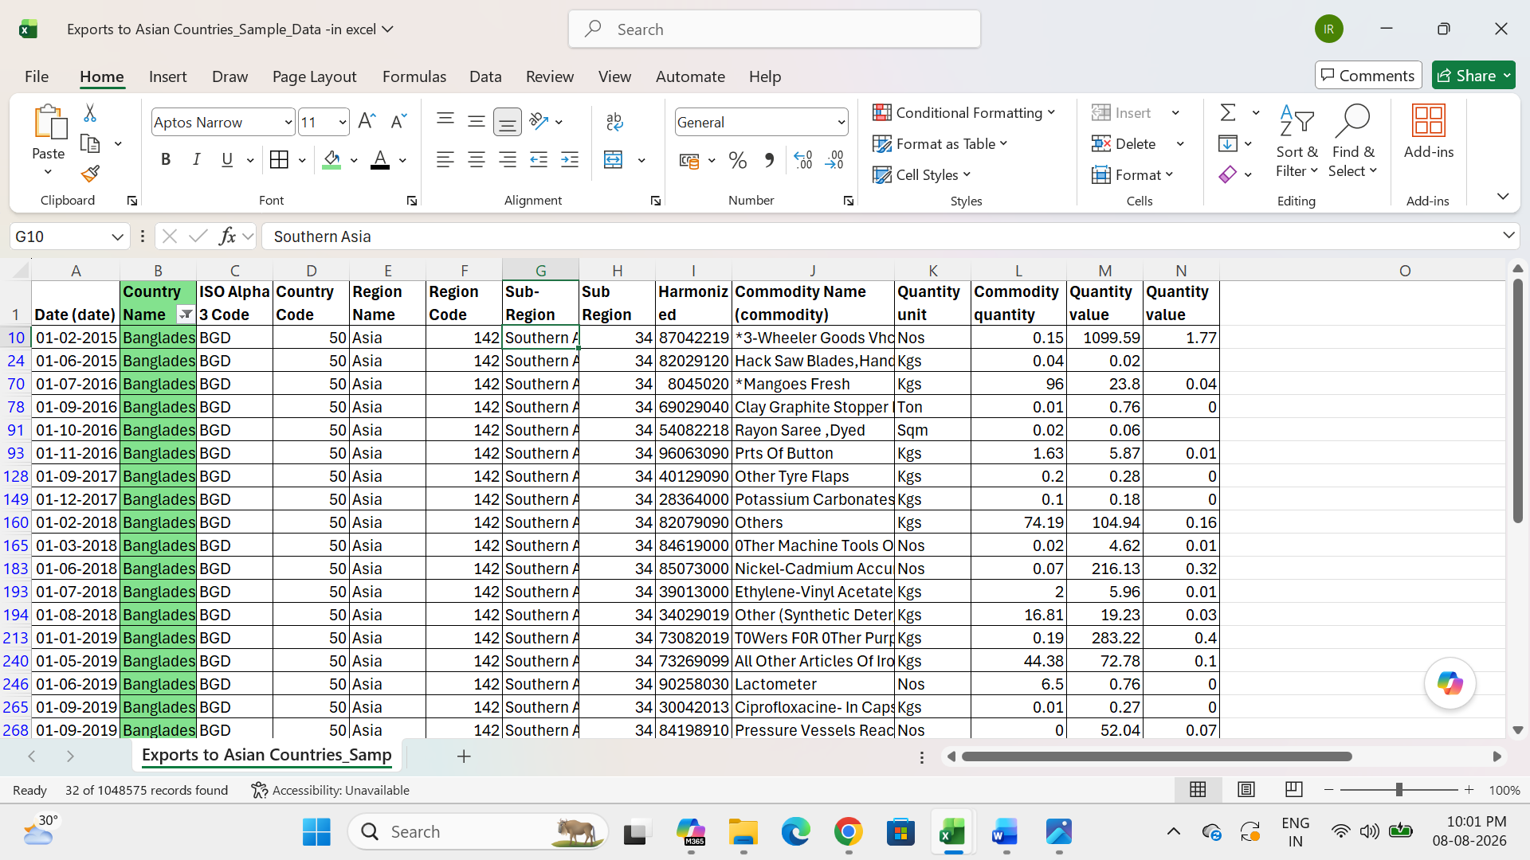

Pivot table:
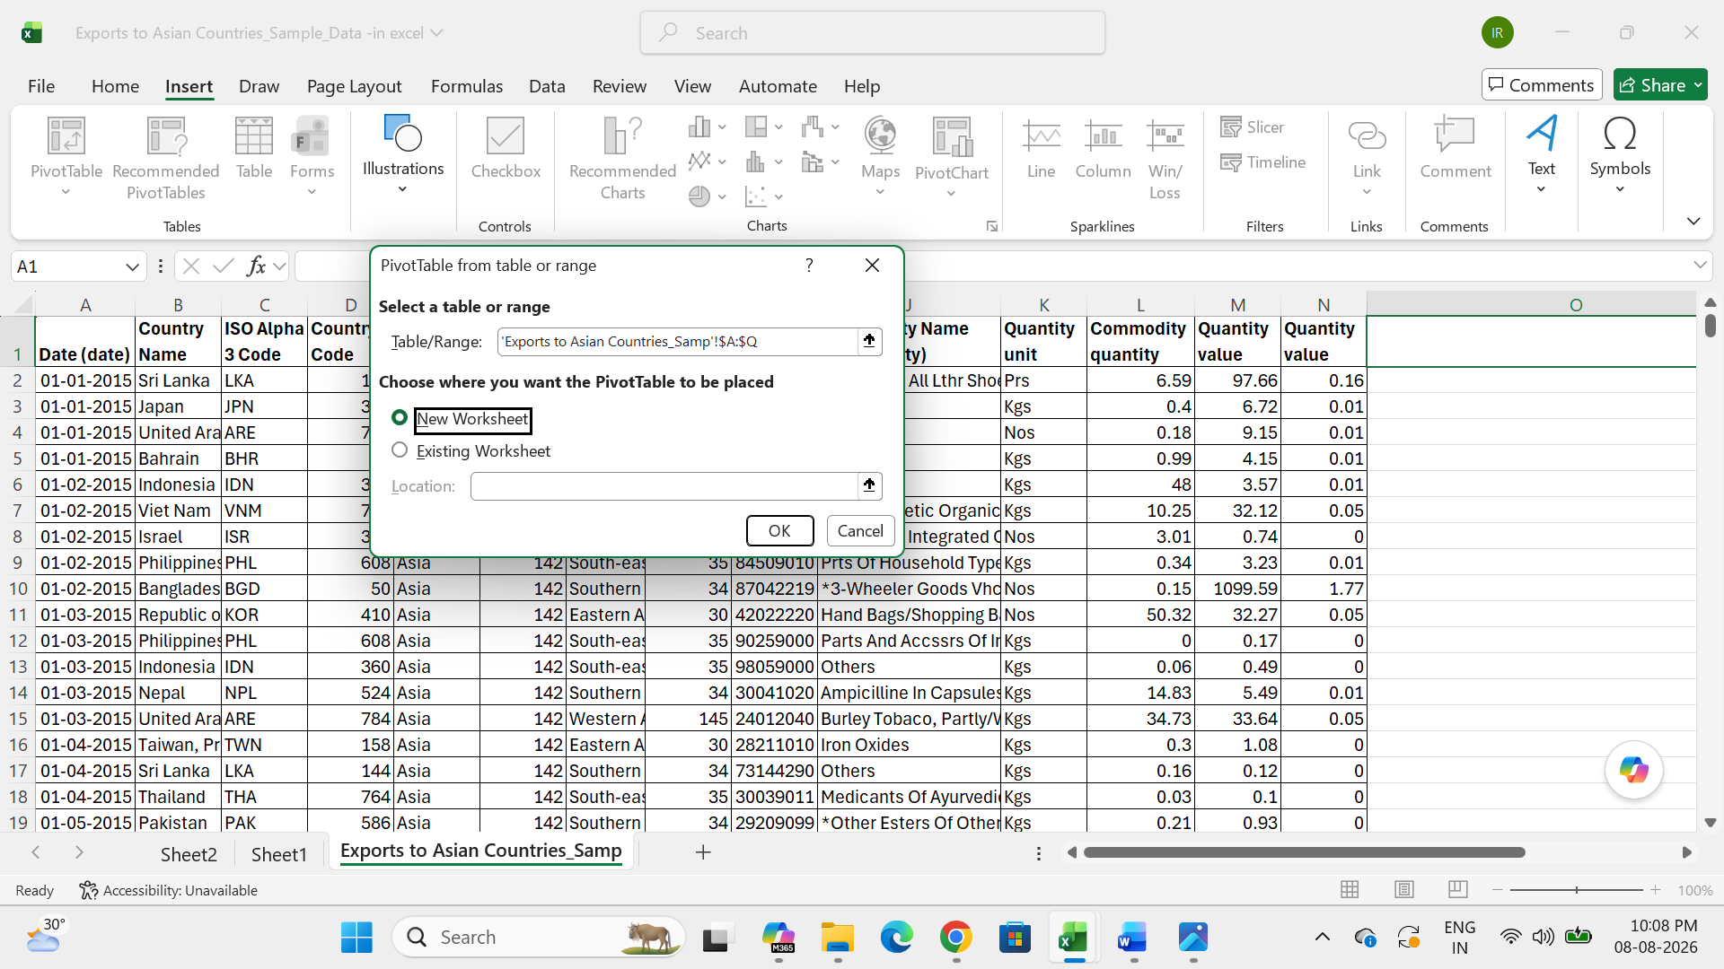
Result:
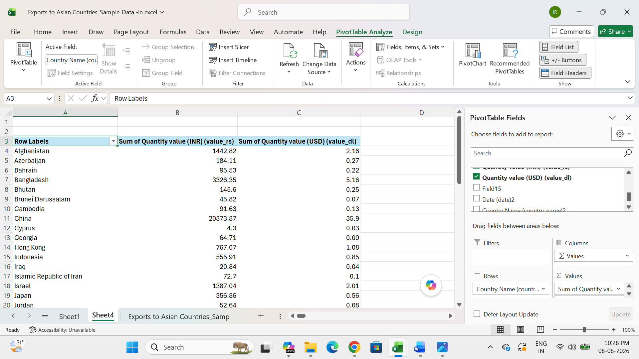

DATA VISUALIZATION USING POWER BI

SYNOPSIS:
- GET DATA
- CLUSTERED BAR CHART
- LINE CHART
- PIE CHART
- SLICERS
- CARDS
- MAP
- FILTERS
- DRILL DOWN
- CONCLUSION

- GET DATA:

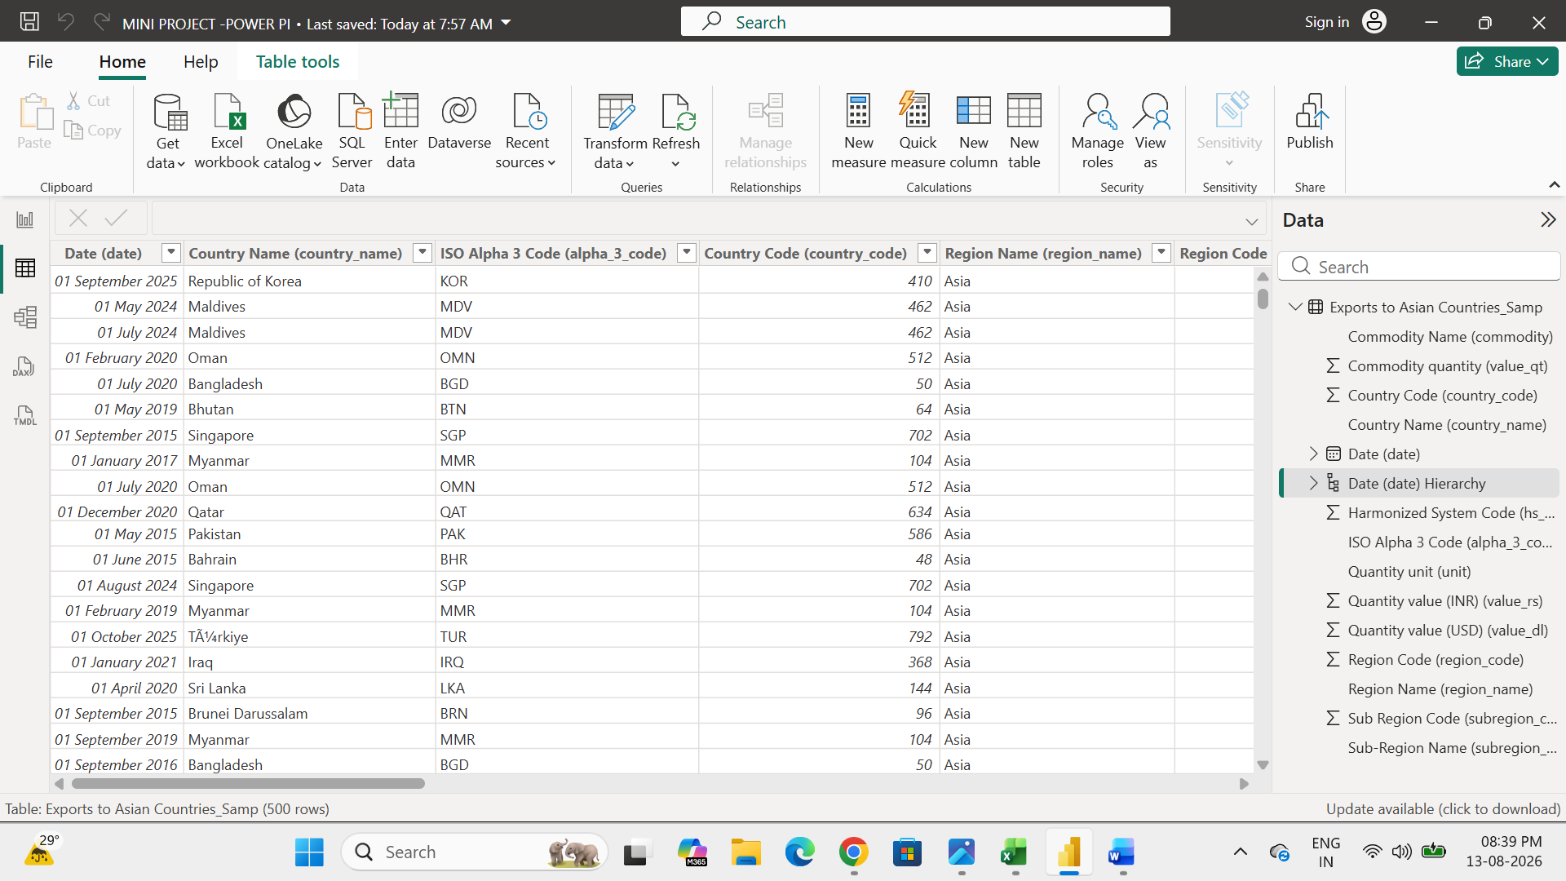

- CLUSTERED BAR CHART:

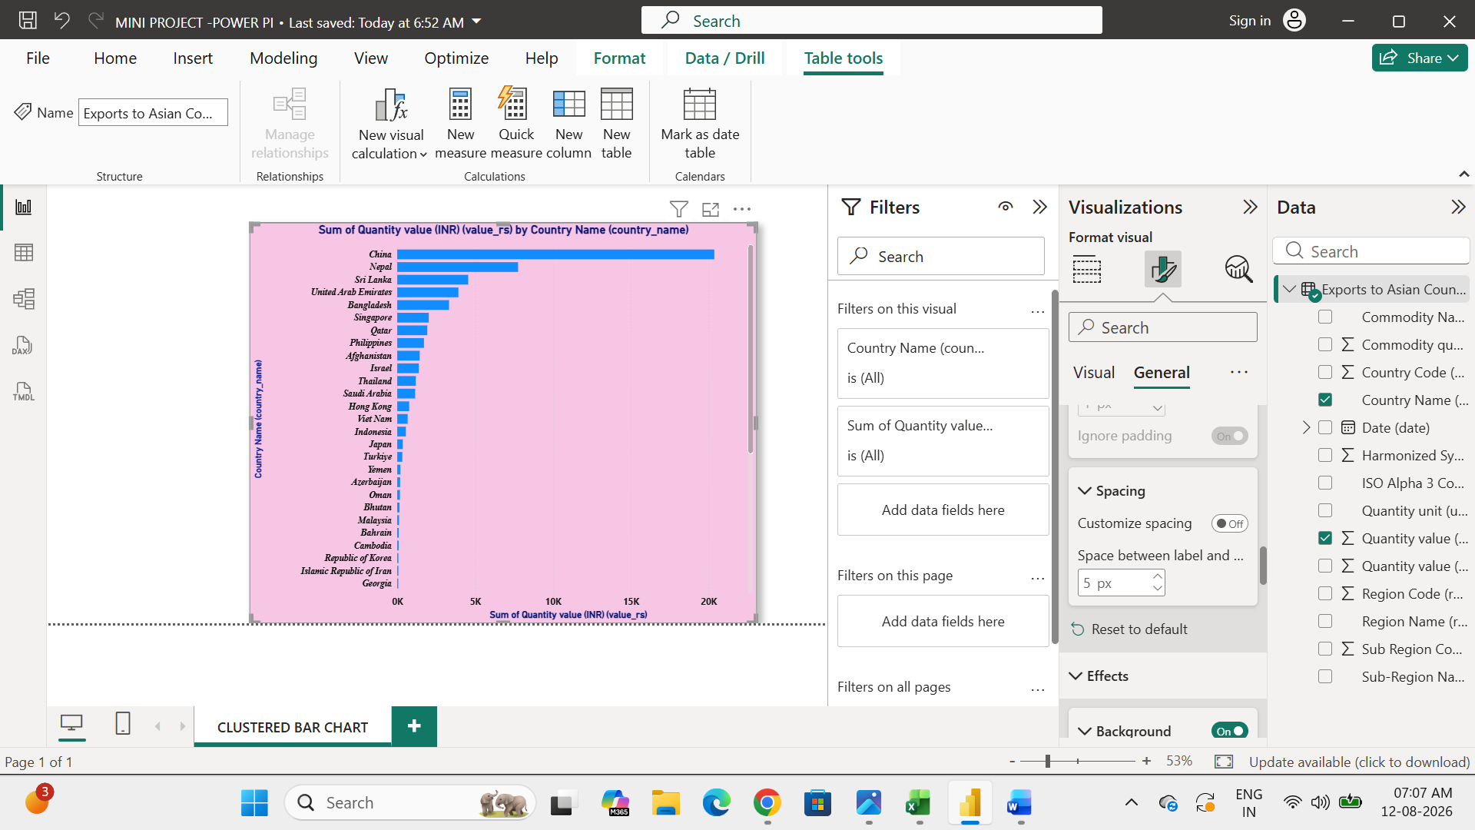

- LINE CHART:

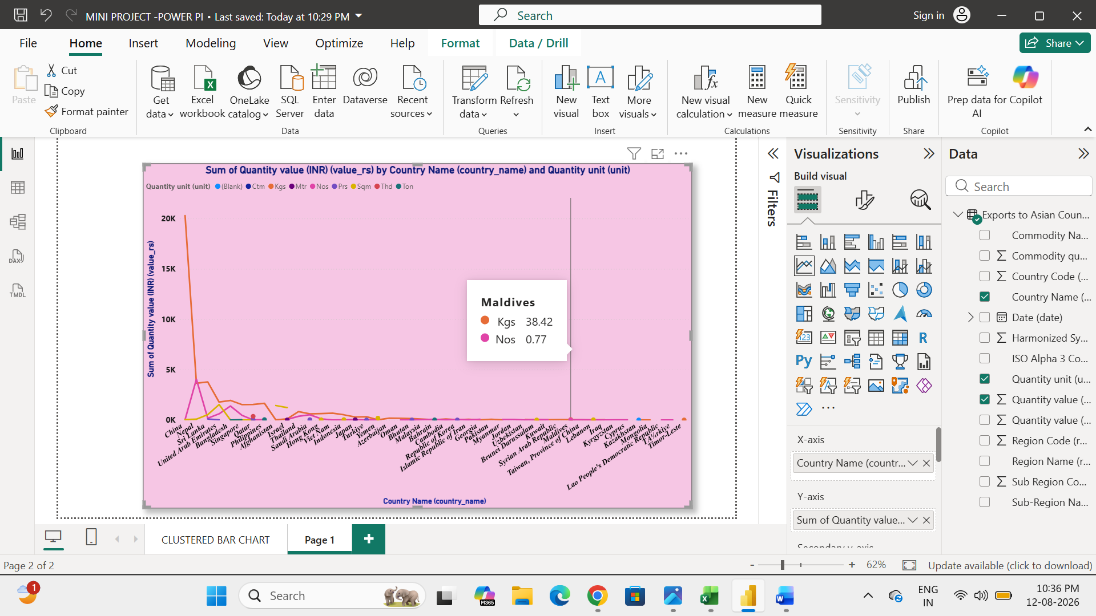

- PIE CHART:
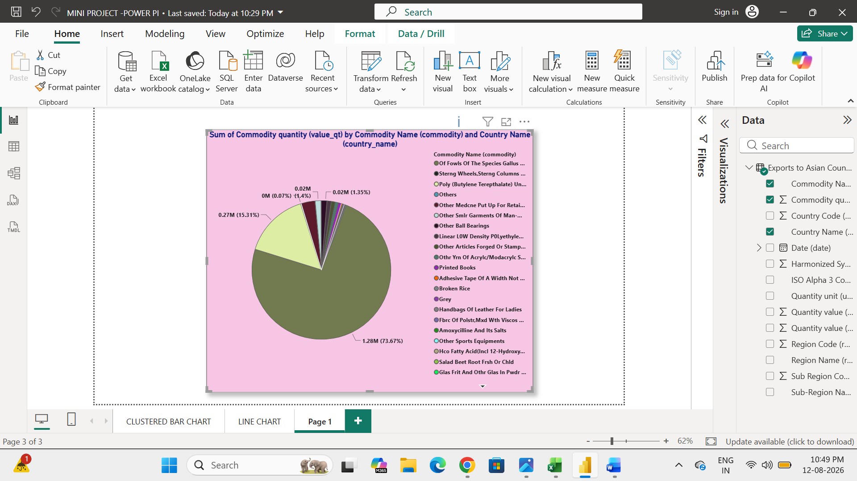

- SLICERS:

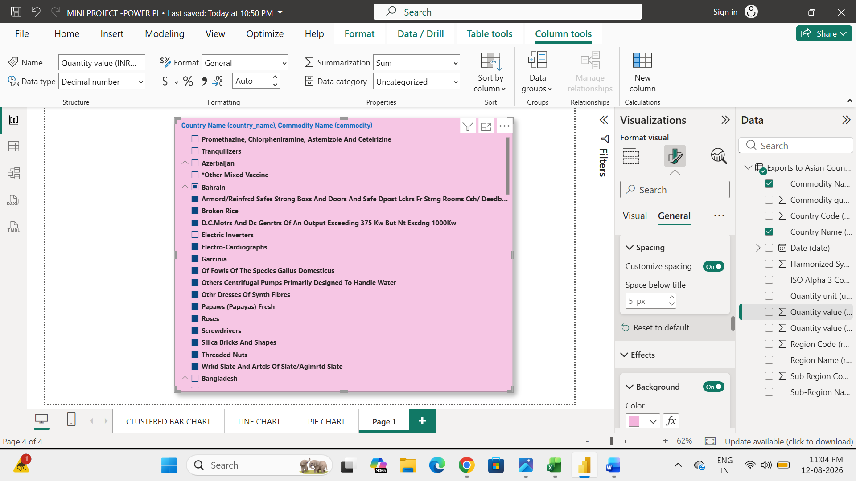

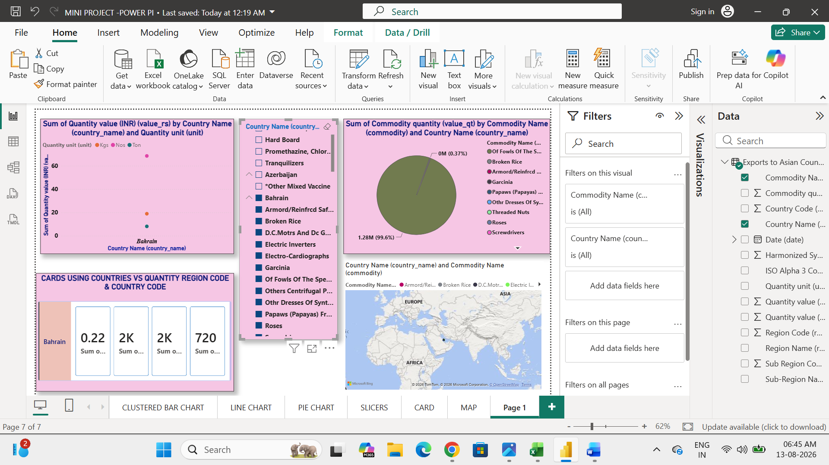

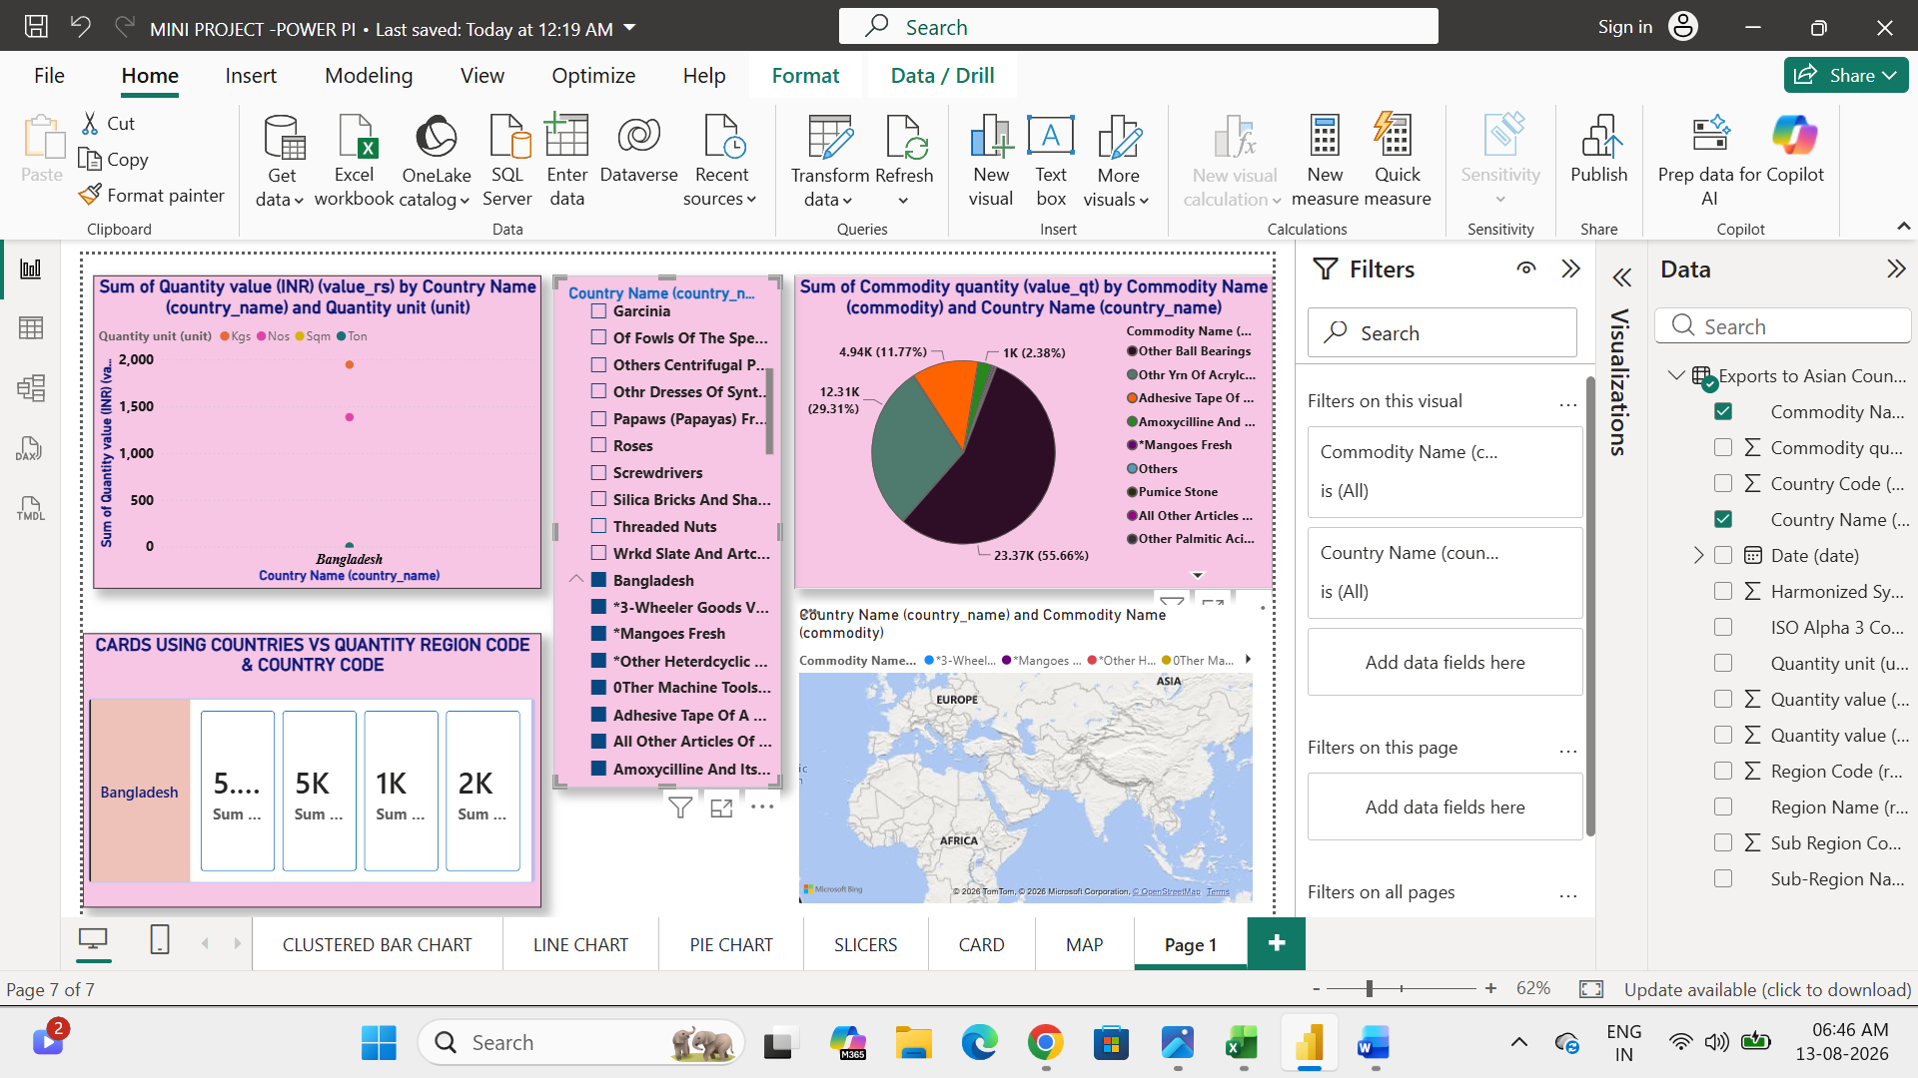

- CARDS:
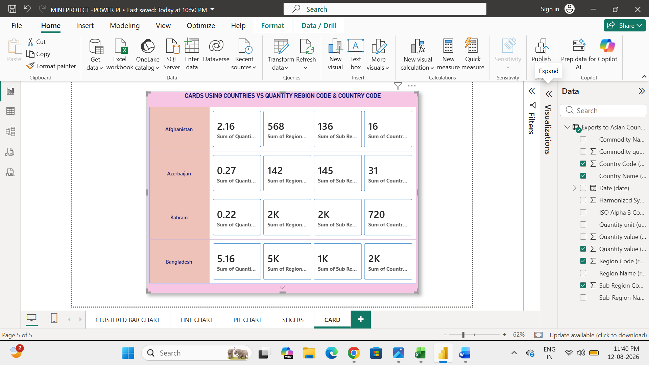
- MAP:

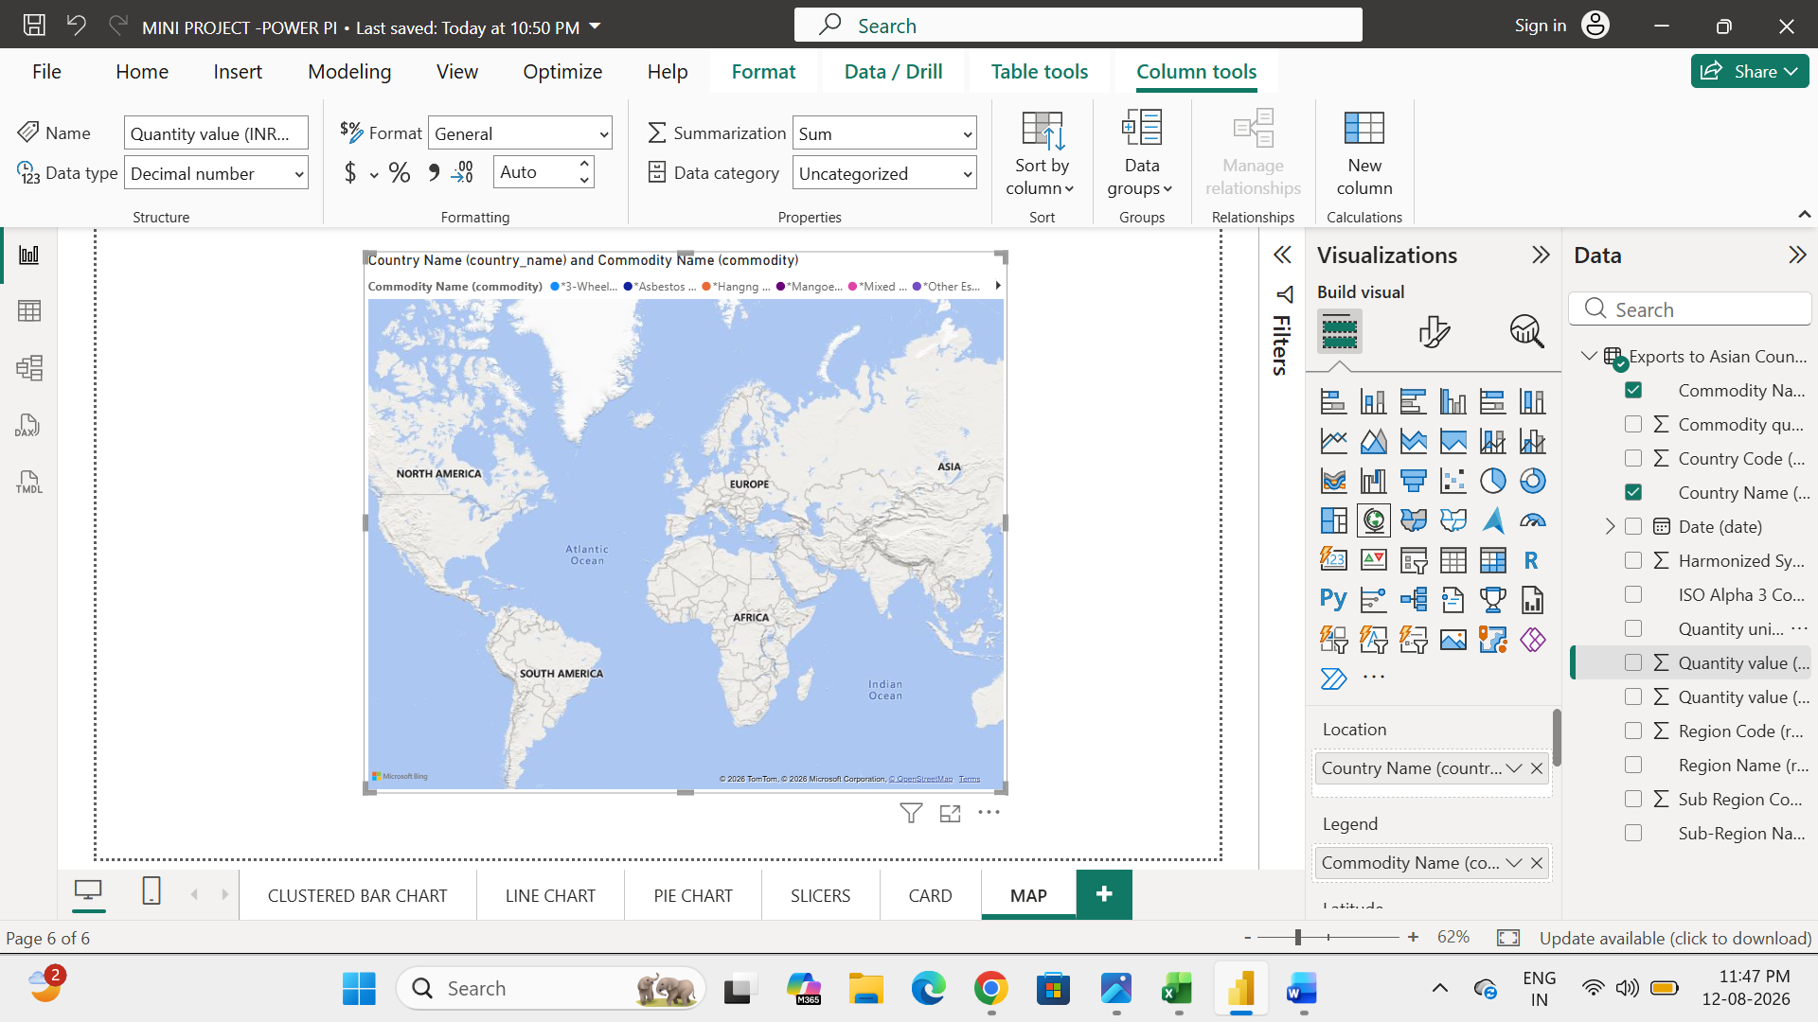

- FILTERS:
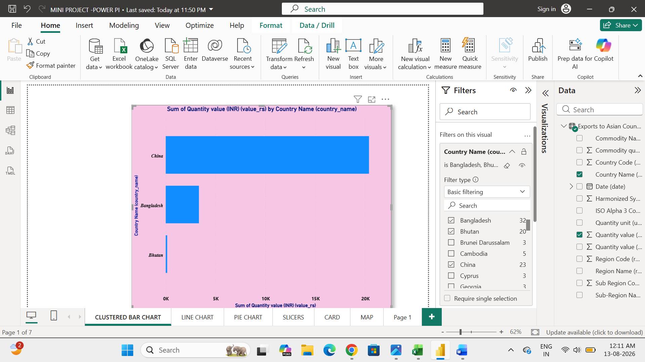

- DRILL DOWN:
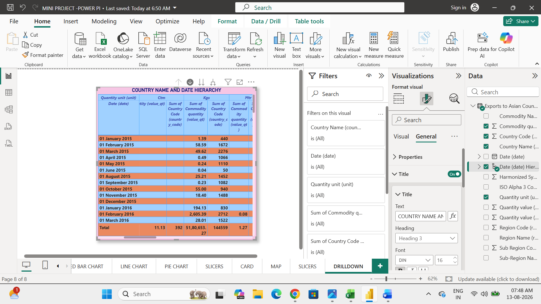

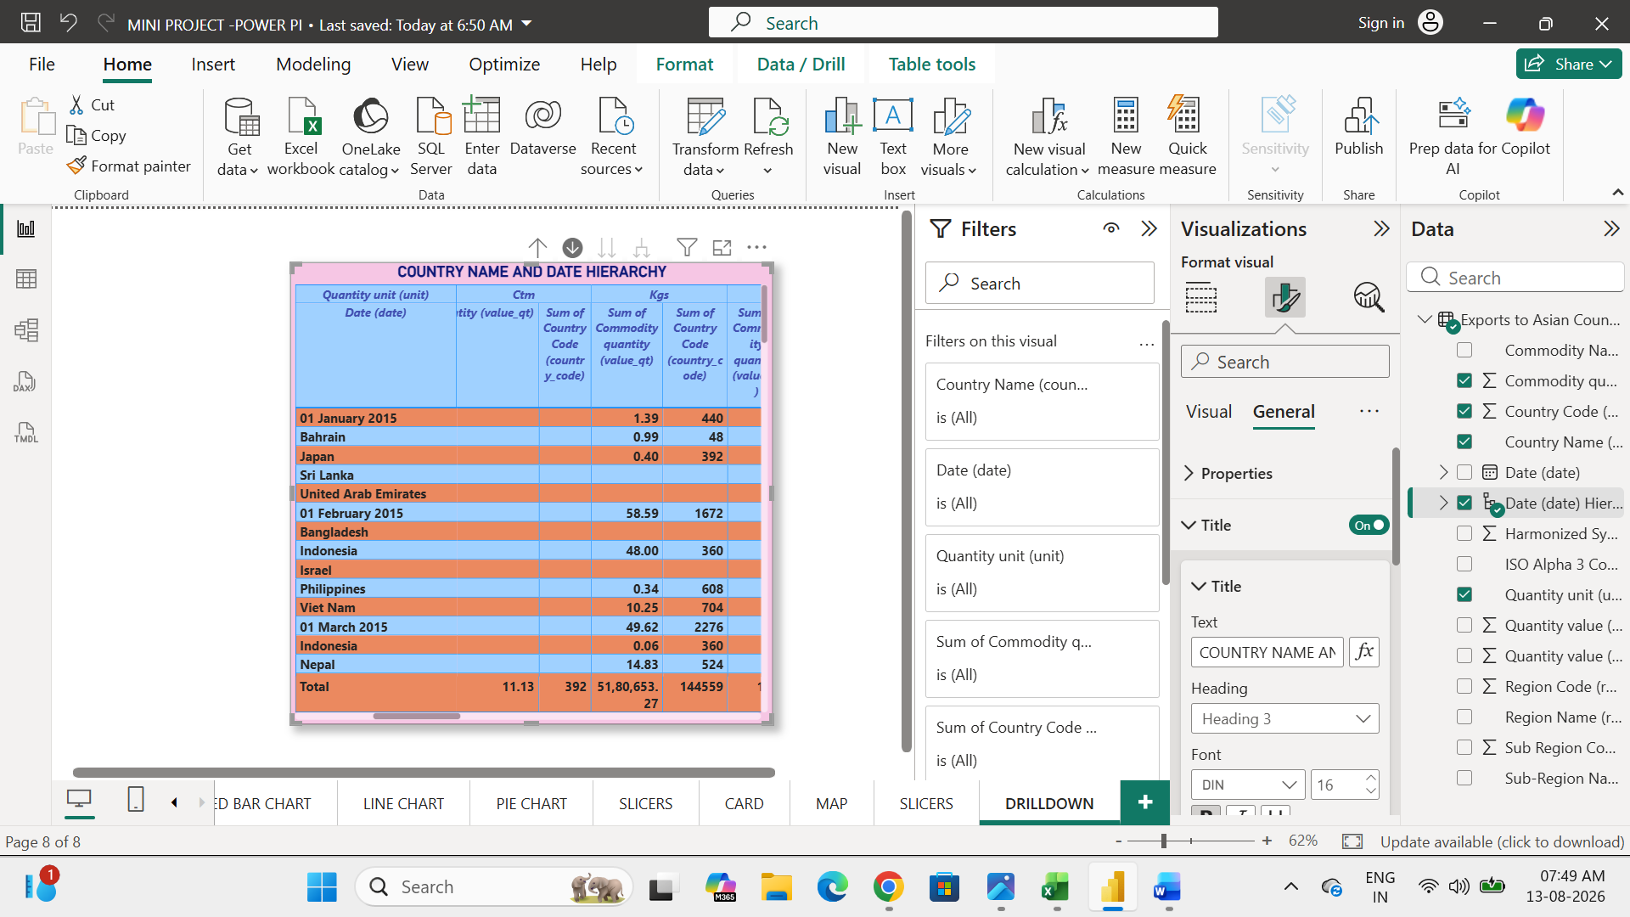

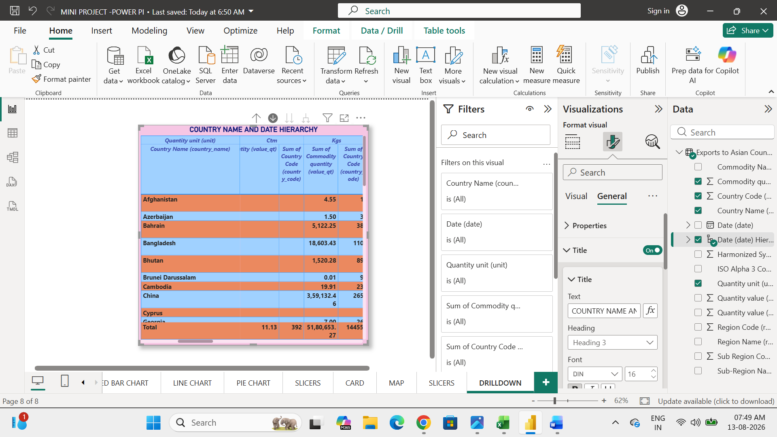

- CONCLUSION:
To produce some types of visualization using power BI visualization. pie chart, line chart, map, matrix, slicers, filters and then drilldown.

